Hirst Wood Nursery School
Accessibility Plan

ACCESSIBILITY STATEMENT

Statement Approval Date | 16th November 2017
Statement Review Date | November 2019
Statutory Statement | Yes
Committee | Finance Premises & Staffing
Statement on website | Yes

At Hirst Wood Nursery School, our values reflect our commitment to a school where there are high expectations of everyone.
Our Values
We enable children to learn through fascination and creativity
enabling them to become self-motivated, independent and confident and involved in their activities and learning.
Everyone in our school is important and included.
We promote an ethos of care, trust and safety where every member of our school community feels that they truly belong and are valued.
We recognise everyone’s uniqueness.
There will be no invisible children here. We recognise everyone’s uniqueness and success. We recognise learning in all its forms and are committed to nurturing lifelong learners.
We make a difference for our families
We provide and source a range of high quality inclusive accessible and integrated services that will make a difference and improve outcome for families.
Building Relationships
We build highly effective relationships with parents and carers and foster their active involvement in their child’s learning and progress.

This Accessibility Plan is drawn up in compliance with current legislation and requirements as specified in Schedule 10, relating to Disability, of the Equality Act 2010. School Governors are accountable for ensuring the implementation, review and reporting of progress of the Accessibility Plan over a prescribed period.

The Equality Act 2010 replaced all existing equality legislation, including the Disability Discrimination Act. The effect of the law is the same as in the past, meaning that “schools cannot unlawfully discriminate against pupils because of sex, race, disability, religion or belief and sexual orientation”.

According to the Equality Act 2010 a person has a disability if:

- He or she has a physical or mental impairment, and

- The impairment has a substantial and long-term adverse effect on his or her ability to carry out normal day-to-day activities.

The Accessibility Plan is structured to complement and support the school’s Equality Objectives, and will similarly be published on the school website. We understand that the Local Authority will monitor the school’s activity under the Equality Act 2010 (and in particular Schedule 10 regarding Accessibility) and will advise upon the compliance with that duty.

Objectives

Hirst Wood Nursery School is committed to providing an environment that enables full curriculum access that values and includes all pupils, staff, parents and visitors regardless of their education, physical, sensory, social, spiritual, emotional and cultural needs. We are committed to taking positive action in the spirit of the Equality Act 2010 with regard to disability and to developing a culture of inclusion, support and awareness within the school.

The school recognises and values parent’s knowledge of their child’s disability and its effect on their ability to carry out everyday activities and respects the parent’s and child’s right to confidentiality.

The Hirst Wood Nursery School Accessibility Plan shows how access is to be improved for disabled pupils, staff and visitors to the school within a given timeframe and anticipating the need to make reasonable adjustments to accommodate their needs where practicable.

The Accessibility Plan contains relevant and timely actions to: -

- Increase access to the curriculum for pupils with a physical disability and/or sensory impairments, expanding the curriculum as necessary to ensure that pupils with a disability are as equally prepared for life as the able-bodied pupils; (If a school fails to do this they are in breach of their duties under the Equalities Act 2010); this covers teaching and learning and the wider curriculum of the school such as participation in after-school clubs, leisure and cultural activities or schools visits – it also covers the provision of specialist or auxiliary aids and equipment, which may assist these pupils in accessing the curriculum within a reasonable timeframe;

- Improve and maintain access to the physical environment of the school, adding specialist facilities as necessary – this covers improvement to the physical environment of the school and physical aids to access education within a reasonable timeframe;

- Improve the delivery of written information to pupils, staff, parents and visitors with disabilities; examples might include letters, information about the school and school events; the information should be made available in various preferred formats within a reasonable timeframe.

The Hirst Wood Nursery School Accessibility Plan relates to the key aspects of physical environment, curriculum and written information.

Whole school training will recognise the need to continue raising awareness for staff and governors on equality issues with reference to the Equality Act 2010.

This Accessibility Plan should be read in conjunction with the following school policies, strategies and documents:

- Behaviour Policy
- Curriculum Policies
- Emergency Plan
- Health & Safety Policy
- School Improvement Plan
- Special Educational Needs Policy
- Teaching and Learning Policy

It may not be feasible to undertake all of the works during the life of this accessibility plan and therefore some items will roll forward into subsequent plans. An accessibility audit will be completed by the school prior to the end of each period covering this plan in order to inform the development of a new Accessibility Plan for the ongoing period.

Equality Impact Assessments will be undertaken as and when school policies are reviewed. The terms of reference for all governors’ committees will include the need to consider Equality and Diversity issues as required by the Equality Act 2010.

The Accessibility Plan will be published on the school website.

The Accessibility Plan will be monitored through the Finance Premises & Staffing committee.

The Accessibility Plan may be monitored by Ofsted during inspection processes in relation to Schedule 10 of the Equality Act 2010.

It is a requirement that the school’s accessibility plan is resourced, implemented, reviewed and revised as necessary and reported on annually. Attached is a set of action plans showing how the school will address the priorities identified in the plan.

The priorities for the Accessibility Plan for our school were identified by:

The Governing Body
- The Executive Headteacher
- Head of School
- School Business Manager
- Site Management team

A plan of the school buildings showing areas of accessibility is shown below

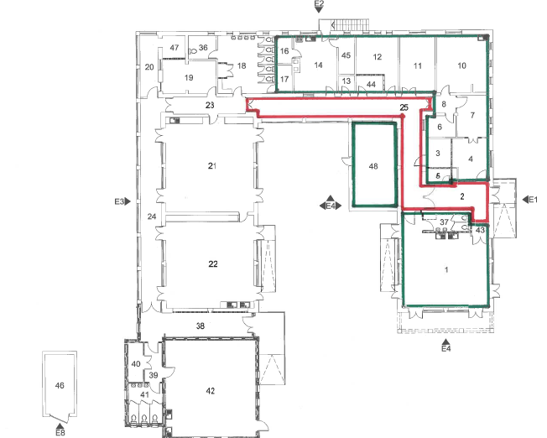
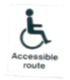

 | Issue | Recommendations | Time Scale | Priority | Cost | Date Completed | Responsibility
1 | Corridors | Keep corridors clear from obstructions. | Immediate | High | None | Ongoing | All staff
2 | Wilderness and sensory garden | Wheelchair accessible from the car park. Ensure non-slip ramp | Ongoing | Medium | Obtain quotes | Ongoing | Site Management
3 | Disabled parking | Spaces provided needs to be repainted | Academic year 2017-18 | Medium | Obtain quotes | Ongoing | Business Manager
4 | Accessible Toilet | In place in Nursery corridor. | Ongoing | Low | None | Ongoing
5 | Changing facilities | In place. | Ongoing | Low | None | Ongoing

Improving Curriculum Access
 | Issue | Recommendations | Time Scale | Priority | Cost | Date Completed | Responsibility
1 | Needs led Teaching | EHT & Head of School to monitor quality of provision through needs led  planning for SEND/EYPP children. | Autumn Term 2017 | High | SLT  release costs |  | Head of School  The Executive Headteacher
2 | Classrooms are organised to promote the participation and independence of all children | Executive Headteacher & Head of School to carry out a Learning walk to ensure that classrooms meet the needs of all children in the class. | Autumn Term 2017 | High | Possible resource implications where gaps are identified
3 | Staff training in the production, implementation and review of Provision maps and IPMs and monitoring systems. | Assistant Headteacher (SPS) for Inclusion to deliver staff training to teaching staff. | Ongoing | High |  | September 2014 | AHT SPS
4 | Staff training in supporting pupils with attachment needs.  25.9.17 | Assistant Headteacher for Inclusion and Specialist TA to deliver training where possible. Identify gaps in knowledge and seek external advice if  necessary | Autumn Term 2017 | High | External specialist costs |  | AHT SPS

 | Issue | Recommendations | Time Scale | Priority | Cost | Date Completed | Responsibility
1 | Availability of written material in alternative formats when specifically  requested | The school will make itself aware of theservices available for converting written information into alternative formats. | Ongoing |  | Not applicable |  | Admin staff
2 | Review documentation on website to check accessibility for parents with English as an Additional Language | The school will include Google translate option on the school website – in order to ensure accessibility for parents with English as an additional language. | Ongoing |  | Not applicable |  | Admin staff

