Week beginning Monday 16th November 2020
Hawthorn

Book of the week:  The Journey Home from Grandpa’s  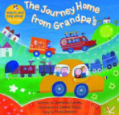 | Familiar story of the week:  A Dark Dark Tale  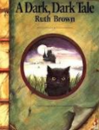 |  | Rhyme of the week:  One Potato, Two Potato  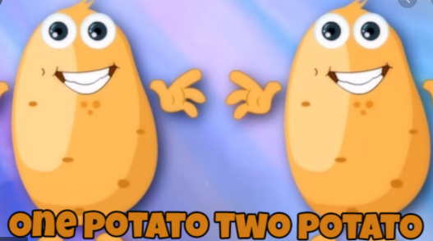
Sound of the week:  M m  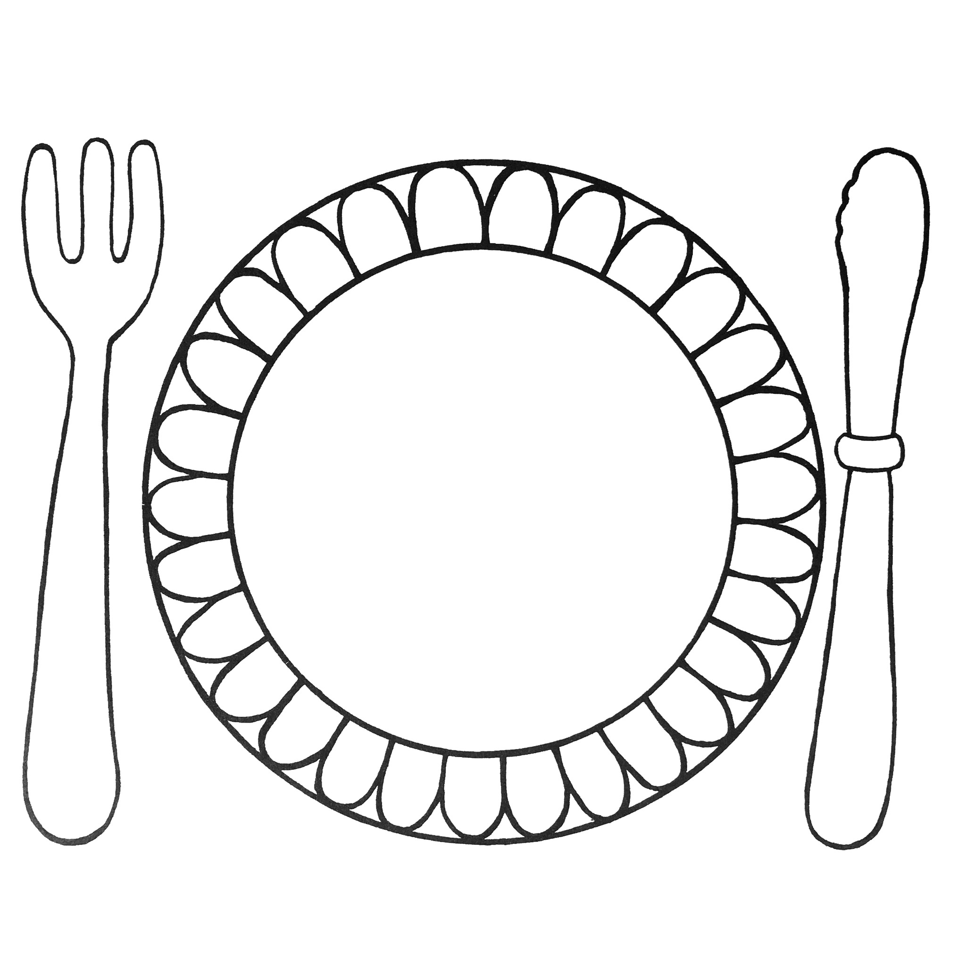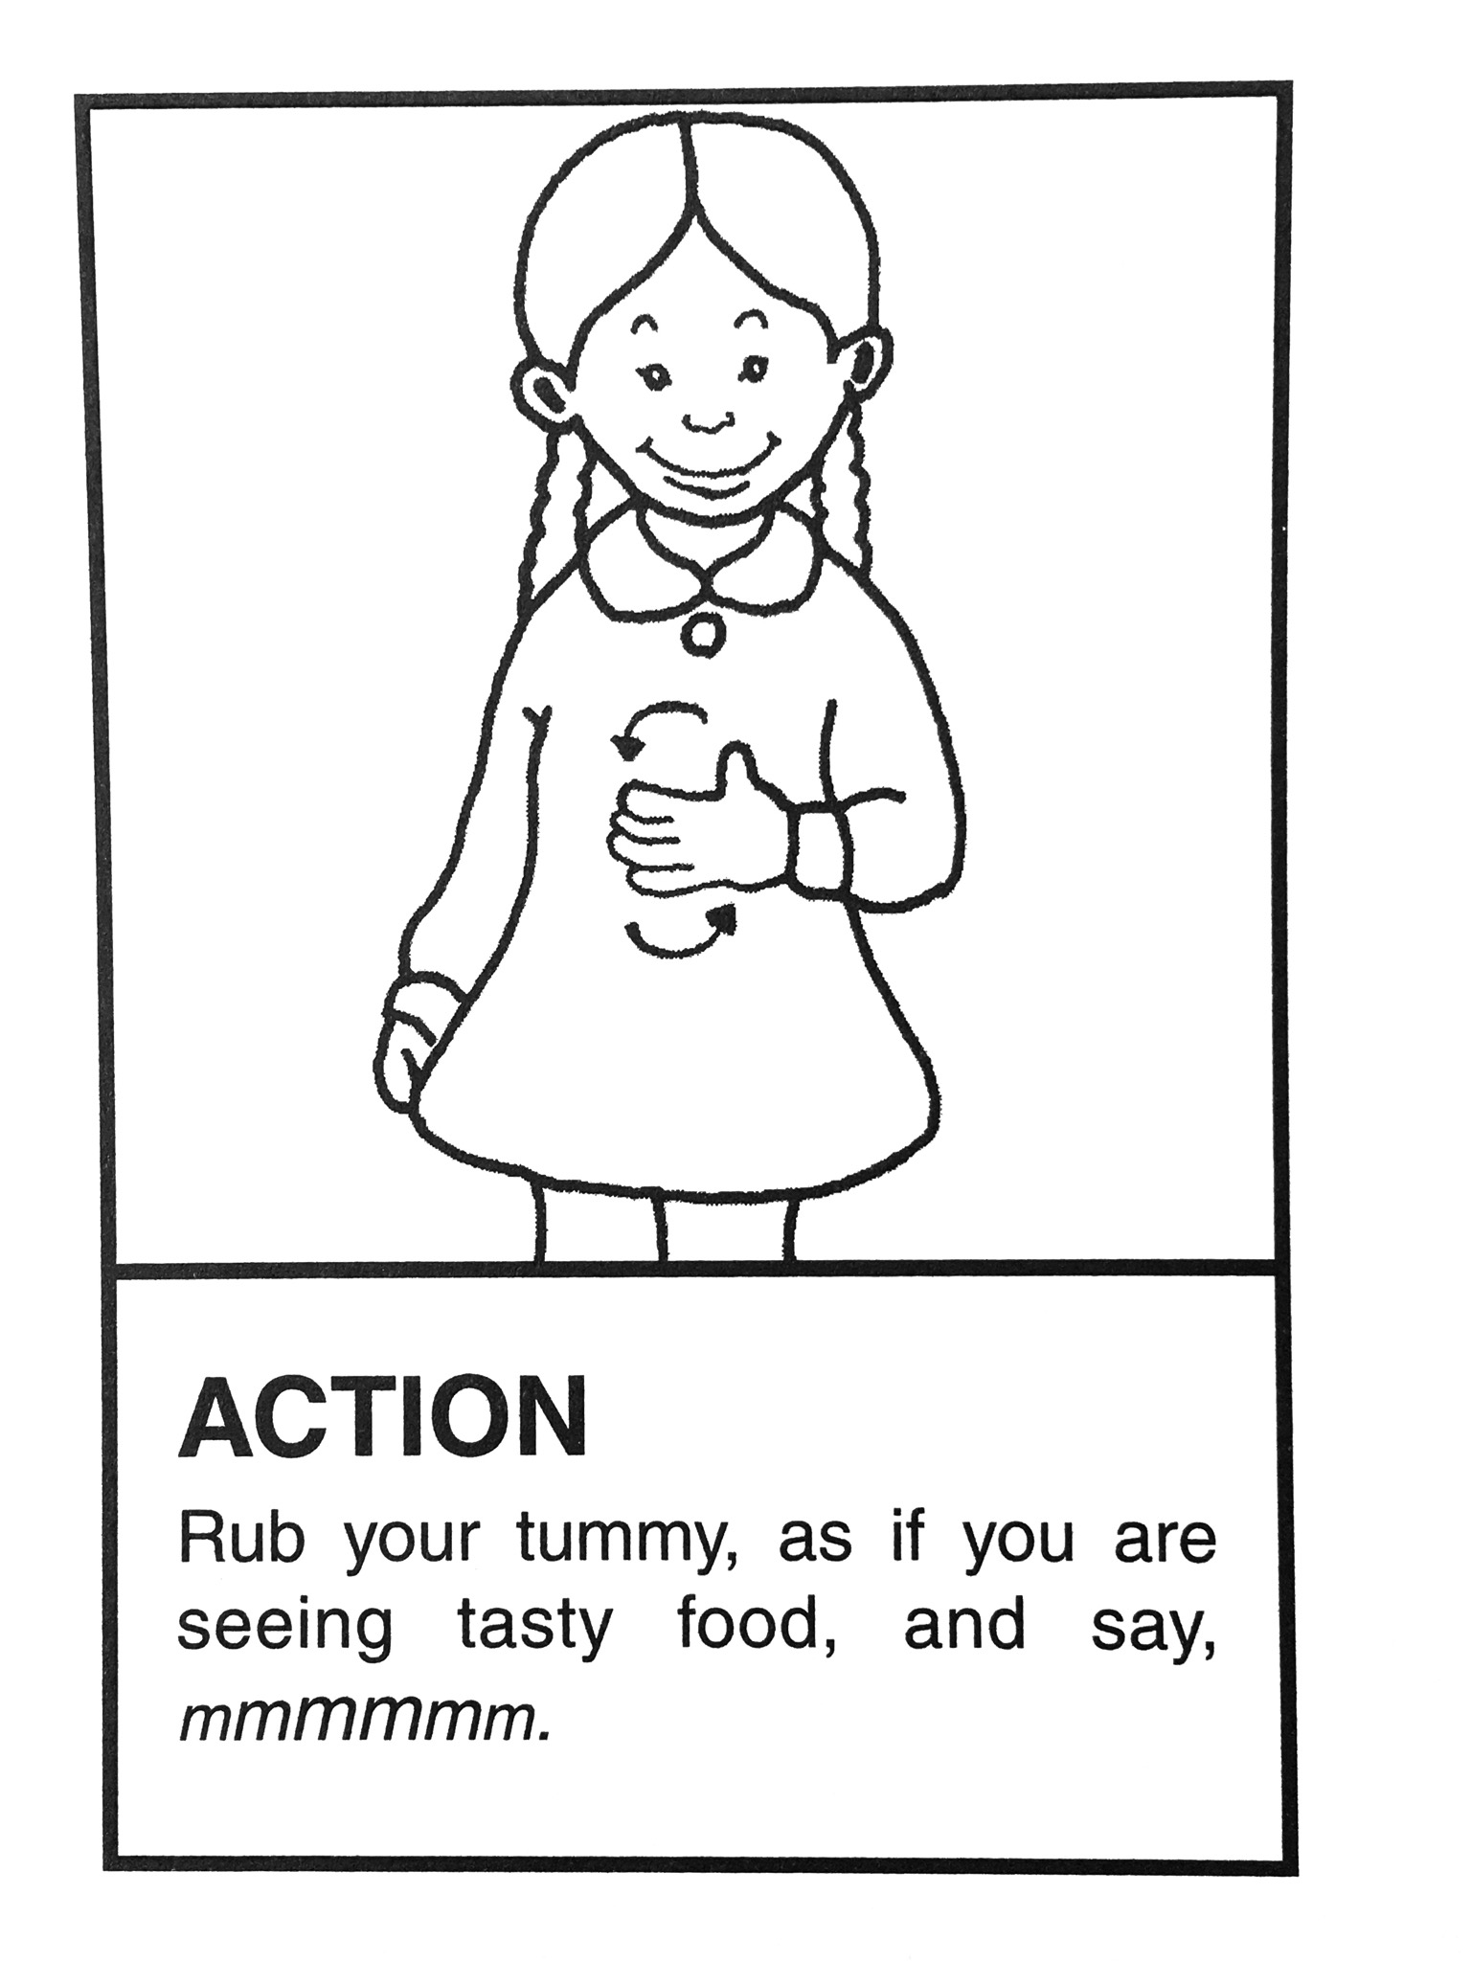 | Number of the week:  7 seven  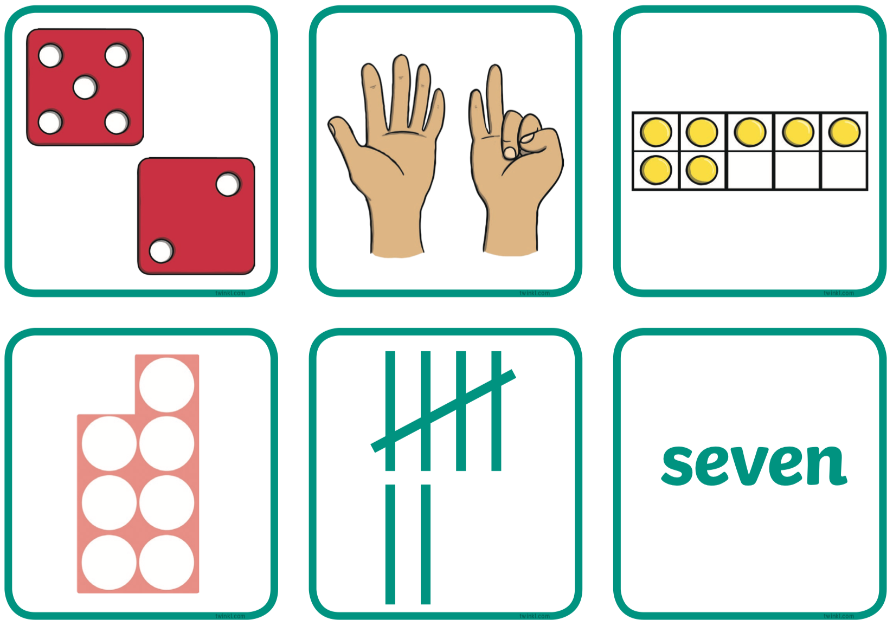 |  | Sign of the week:  Please and  Thank you  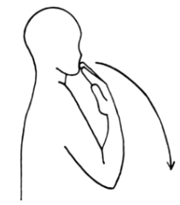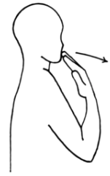
Indoor learning:  - Learning to recognise numbers playing maths games  - Going for a listening walk  - Learning how to build for a purpose creating houses in junk modelling  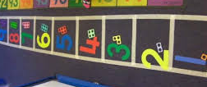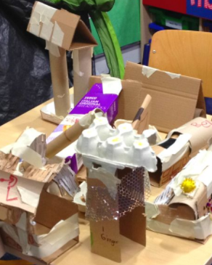 |  | Outdoor learning:  - Learning about road safety  - Practising our two and three wheeled cycling skills  - Playing number splat  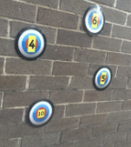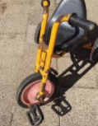
We are here to help. If you have any questions or concerns please telephone the office.
Sally, Richelle, Sam and Laiba

