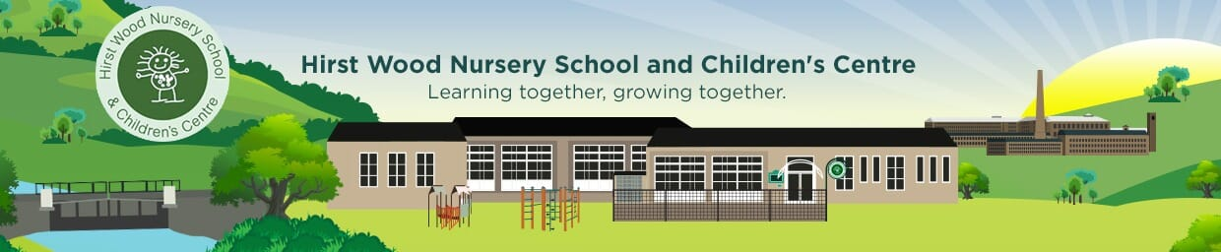

Hirst Wood Nursery School chargeable extras 2026
Description | Unit | Unit price | Line total
Free entitlement hours –15 or 30 hours per week (must not have a charge). Term time only | Weekly | Free | Free
Additional hours purchased  Morning session 7.45 to 8.55  After School session 3.20 to 5.45  Half day session 9.00 to 11.30 / 12.45 to 3.15  Lunchtime session 11.30 to 12.45  Full day session 9.00 to 3.15 | Daily | £7.00  £14.00  £19.50  £9.00  £49.50 | Daily charge if parents request additional sessions
Lunch provided by Facilities  Management  Snacks (twice daily AM & PM) | Daily | £2.35 per day  Voluntary contribution | £2.35 daily  Voluntary contribution
Consumables (for example sun cream) | Free | Free | Free
Additional voluntary services (for example forest school sessions) | Ad Hoc | Free | Free
 |  | Total | £2.35 per day lunch + any additional sessions  & contribution towards snack

For children who are not yet continent, we ask parents & carers to provide School with your own nappies and barrier cream if required.

