Week beginning Monday 9th March 2020
This week in Willow

Book of the week:  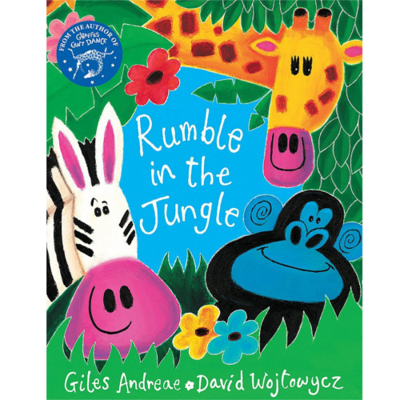  Rumble in the Jungle | Rhyme of the week:  An Elephant Goes Like This and That |  | Sign of the week:  sad
Sounds of the week:  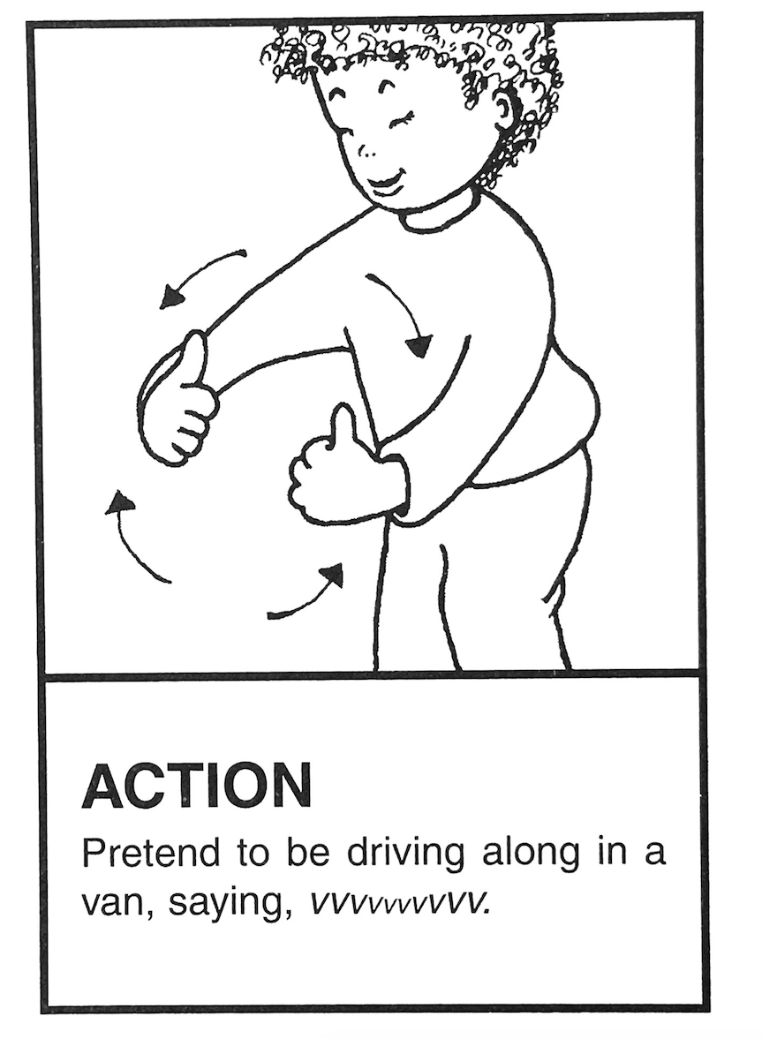  V v | 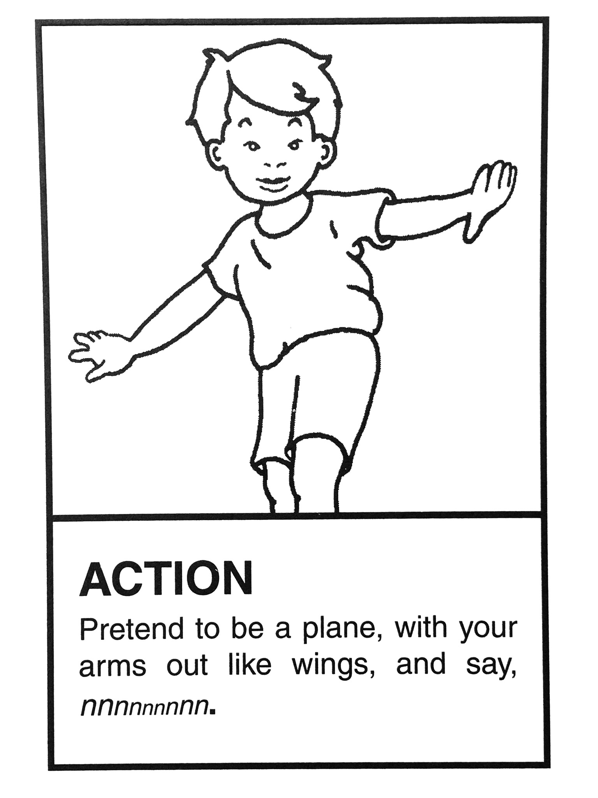  N n |  | Number of the week:  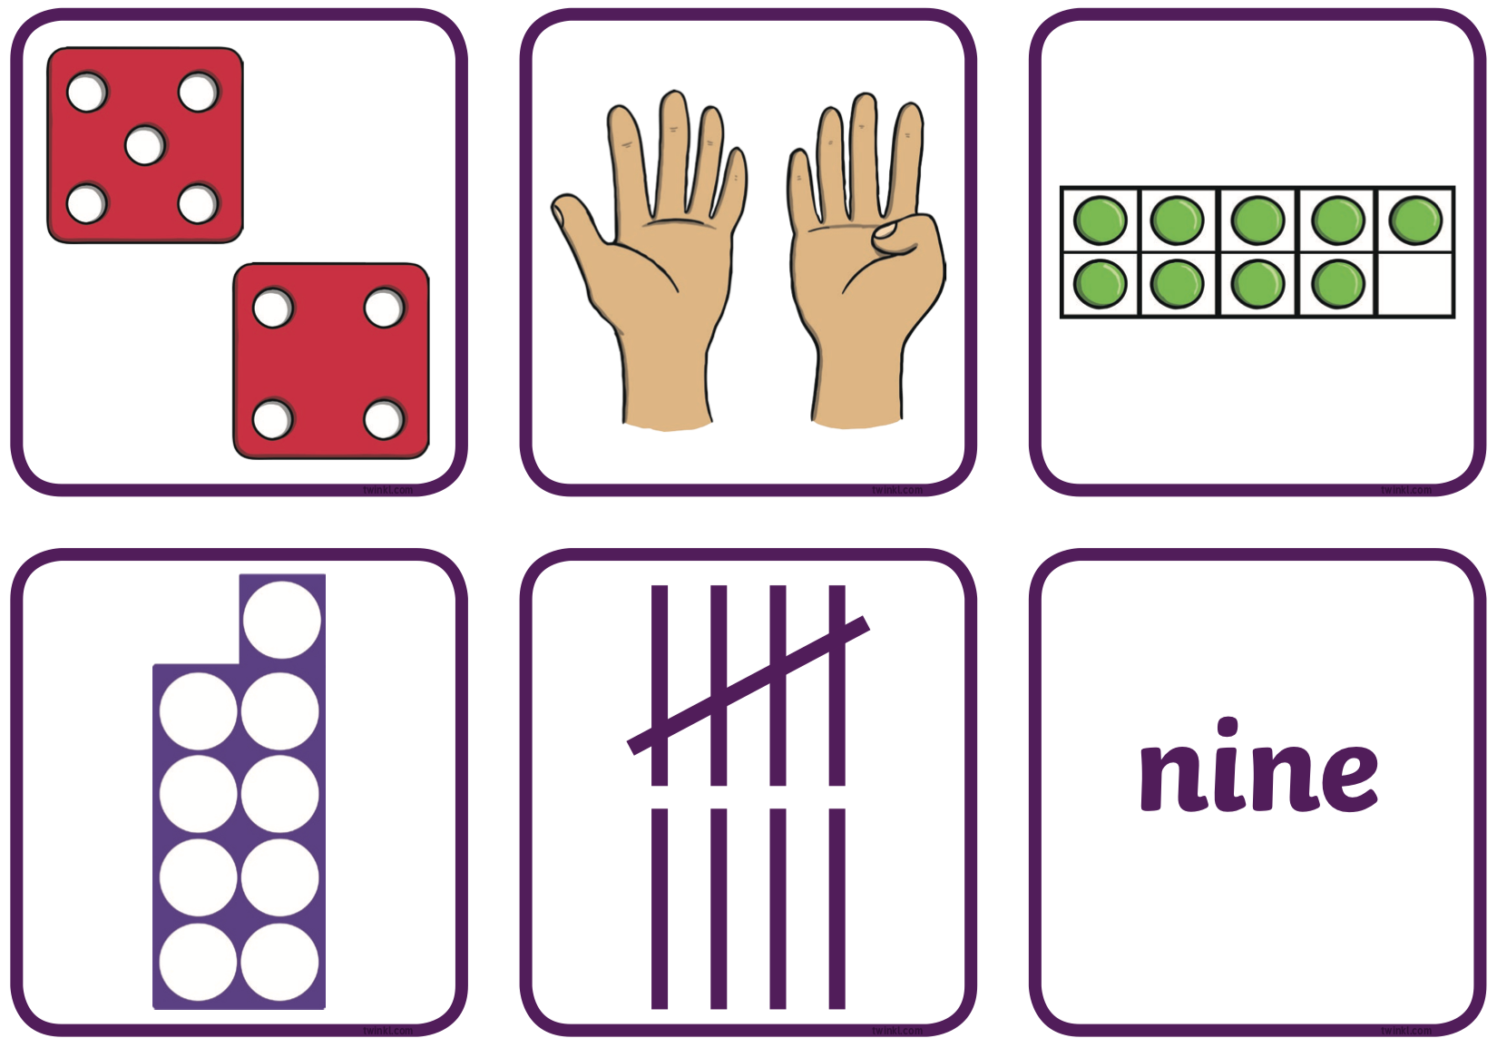  9
Outdoors:  - developing physical skills  - playing games to develop Maths and literacy skills  - learning about the natural world  At Forest School:  - receiving a letter from a magical character  - looking for signs of spring |  | Indoors:  - counting and calculating  - reading books and discussing how the characters feel  - playing letter recognition games  - playing instruments and singing rhymes  Dates for your diary:  Wednesday 11th March 9.00-9.30am – Stay and Play for Grandparents  Monday 30th March 9.00-9.30am – Stay and Learn about Maths  Wednesday 1st April – Chocolate Tombola
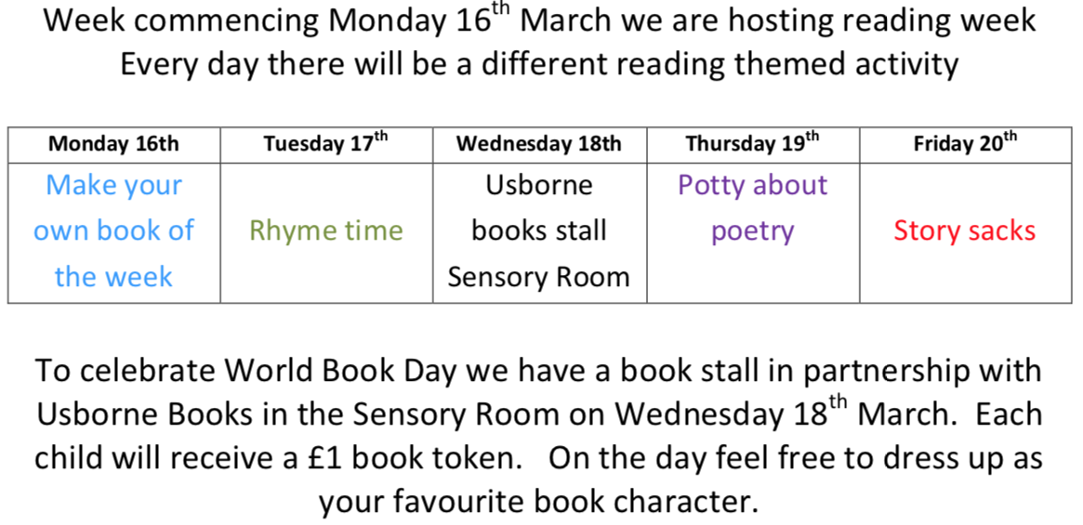 |  |  |  | We are here to help. If you have any questions or concerns please talk to your child’s keyworker or any of the staff in Willow. Rachel, Ruth, Angie and Sarah

