Week beginning Monday 30th November 2020
Hawthorn

Book of the week:  Stick Man  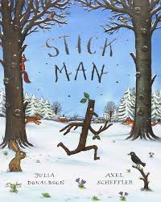 | Familiar story of the week:  The Three Billy Goats Gruff  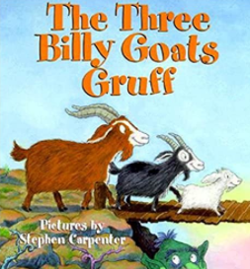 |  | Rhyme of the week:  5 Little Men in a Flying Saucer  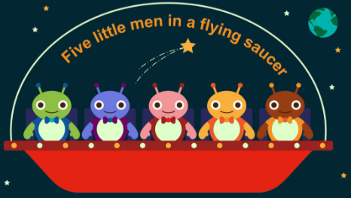
Sound of the week:  G g  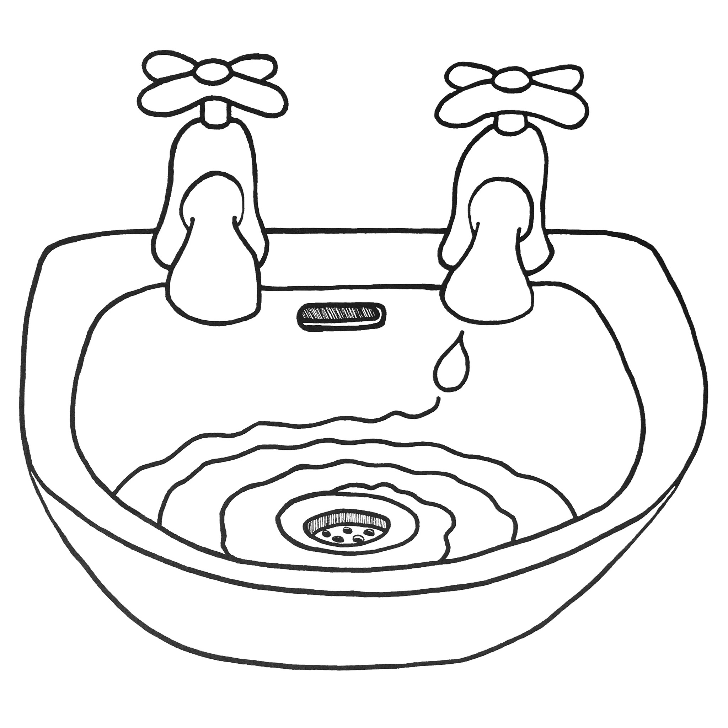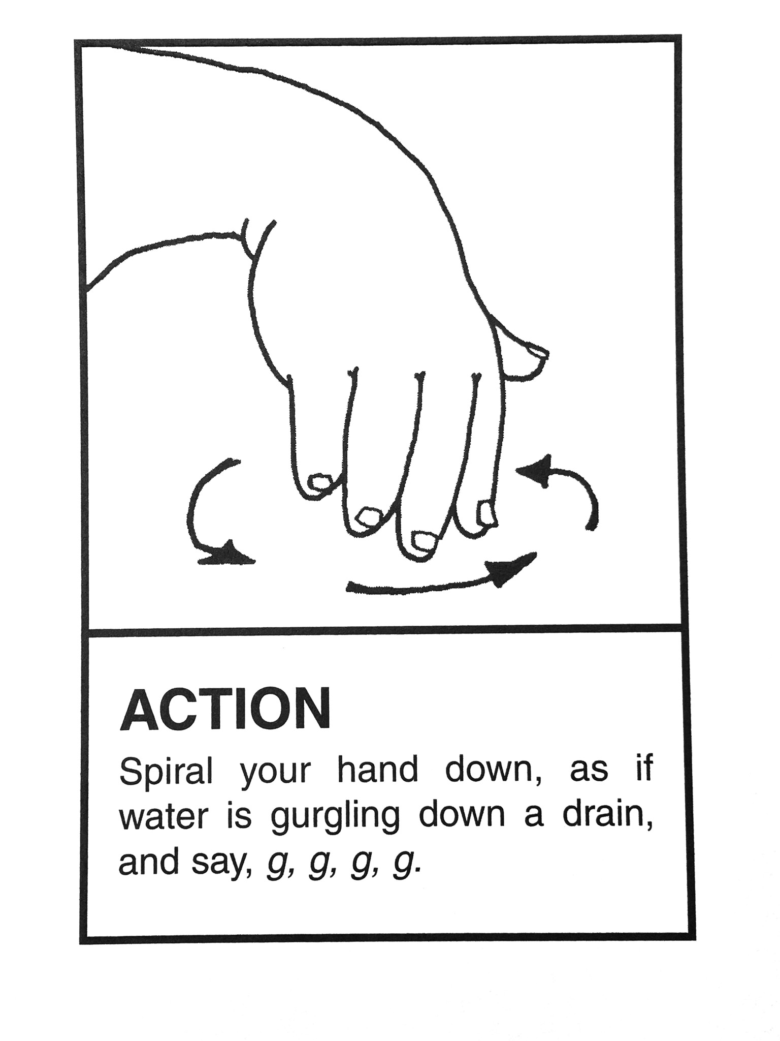 | Number of the week:  9 nine  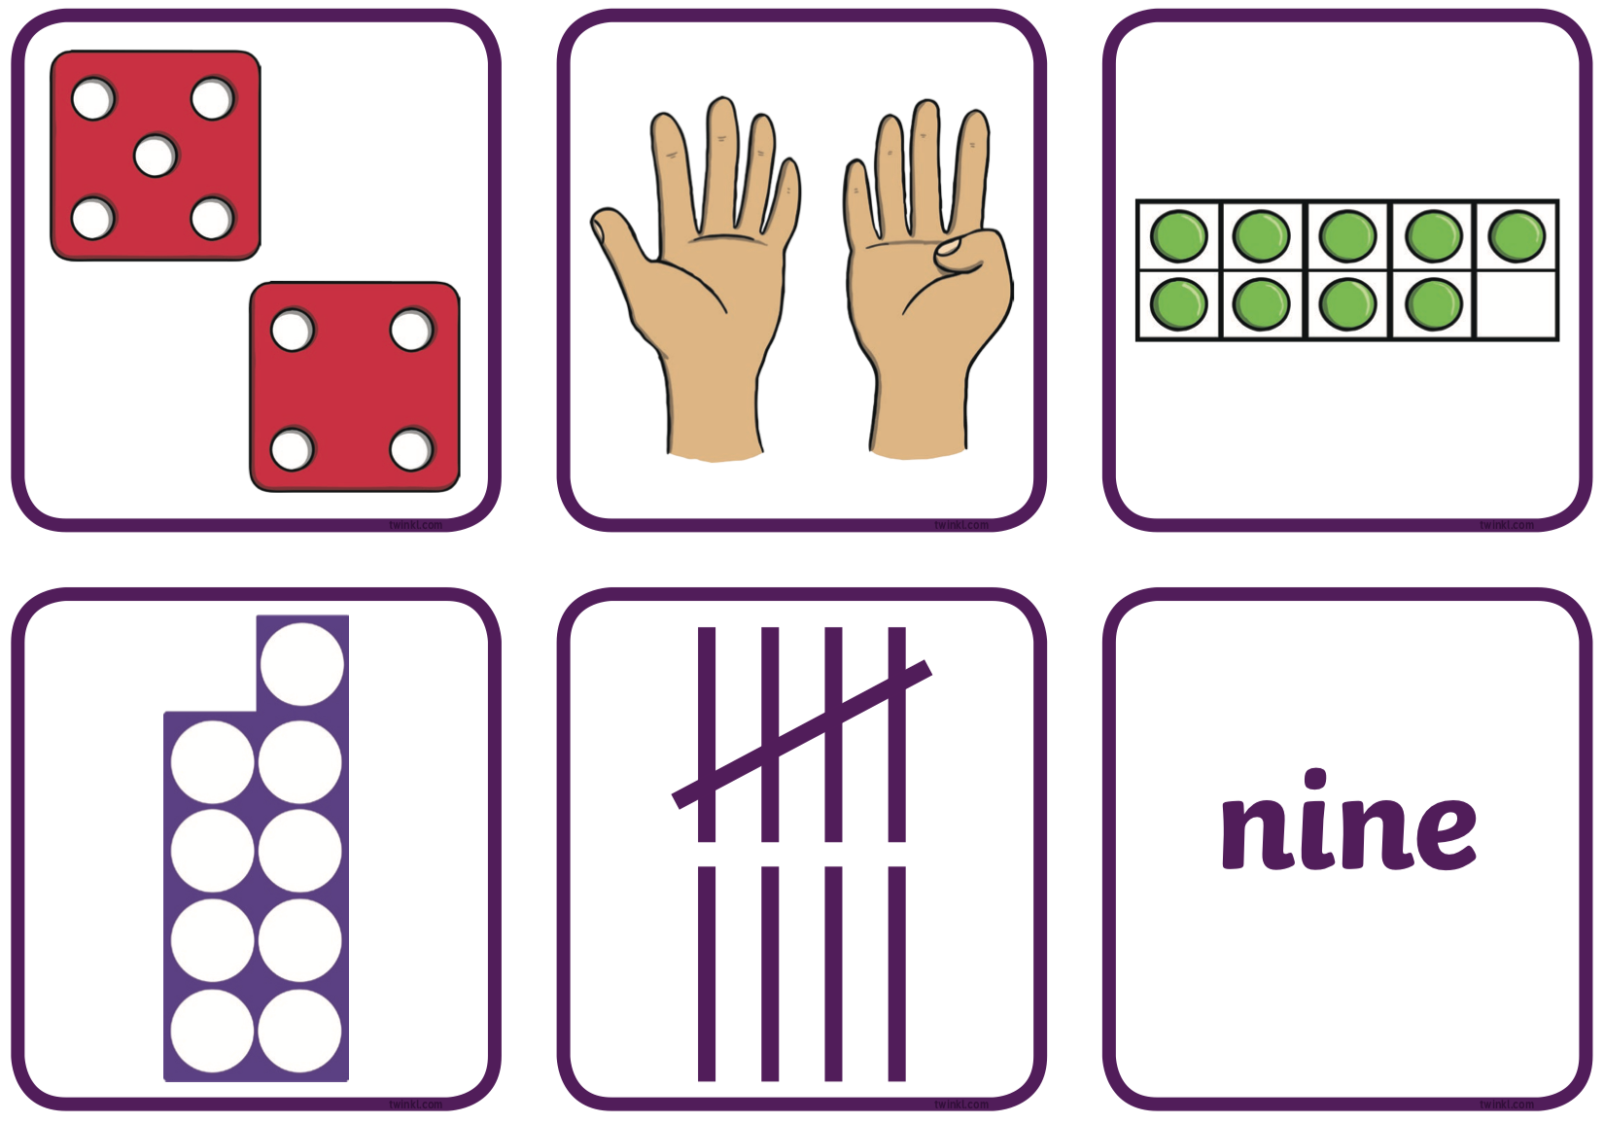 |  | Sign of the week:  Good morning  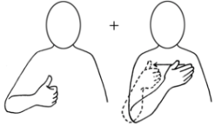
Indoor learning:  - Investigating length  - Constructing bridges  - Being imaginative creating lollipop people  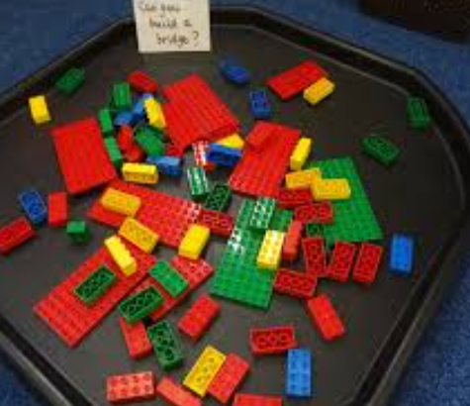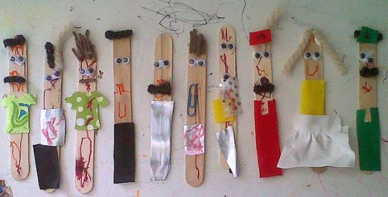 |  | Outdoor learning:  - Using natural resources to create stick men  - Developing our climbing skills  - Observing seasonal changes in our environment  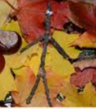
We are here to help. If you have any questions or concerns please telephone the office.
Sally, Richelle, Sam and Laiba

