Week beginning: 20th September 2021
This week in Maple

Book of the week:  Pip and Posy and The Bedtime Frog  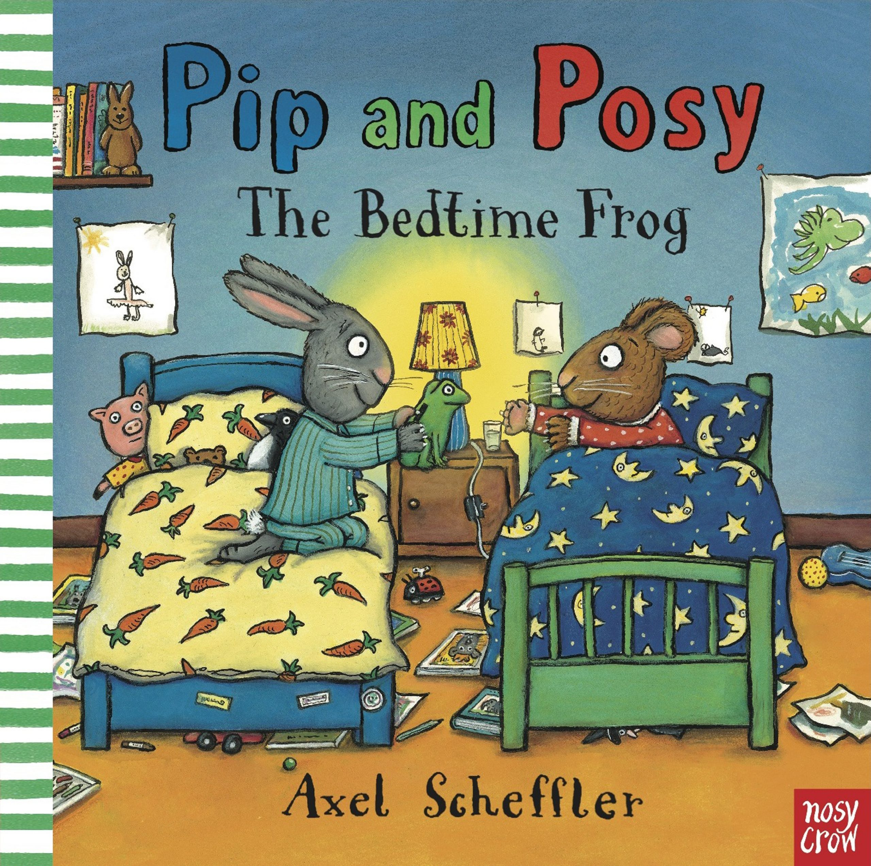 | Rhyme of the week:  Sleeping Bunnies  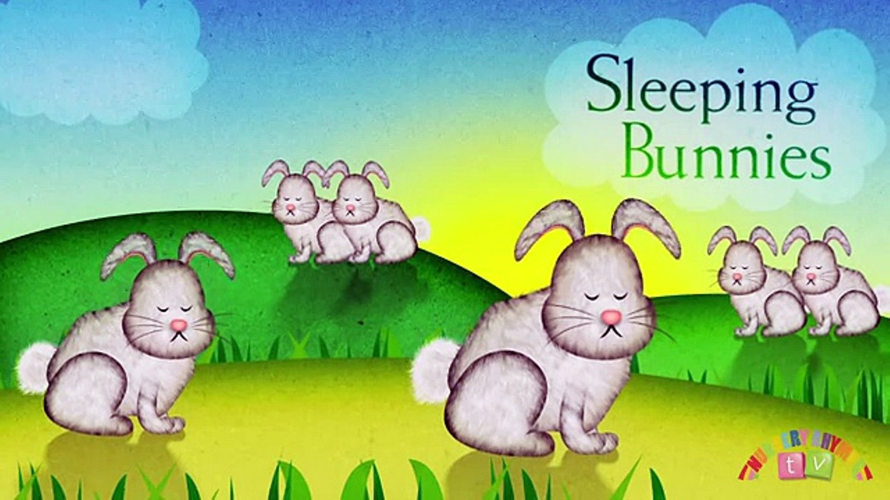 |  | Help At Home:  This week we will be talking about what is special to us. Encourage your child to talk to you about what is special to them? They could even draw a picture and bring it into nursery to share with us?
Indoor learning:  - Talking about and sharing our favourite stories and rhymes.  - Using different tools to make marks.  - Identifying different 2D shapes.  - Counting small numbers of objects.  - Continuing to explore our new classroom. |  | Outdoor learning:  - Noticing how the trees are changing and watching for falling leaves.  - Practicing our climbing using nursery equipment.  - Exploring some of our new areas, including the large sand pit and creative studio.  - Learning how to dress for the weather. Do we need a coat or a sunhat?
Dates for your diary:
w/b - 27/9
We will be reading the story ‘Monkey Puzzle.’ It would be great if you could send in some family photographs for us to discuss with your child. These can be a hard copy or via email to the school office.

w/b - 18/10
(Weds) We will be reading ‘Where’s My Teddy’ this is an opportunity for your child to bring a special teddy into nursery to share with their friends.

We are here to help. If you have any questions or concerns please talk to your child’s keyworker or any of the staff in Maple.

