SEND Information Report, November 2024
Head Teacher & SENDCo: Jayne Taylor
Specialist Teacher: Rosy Vincenzi
For information about our Policy for Special Educational Needs & Disabilities, and our local offer, please refer to the school website www.hirstwoodnscc.co.uk

Hirst Wood Nursery School is an inclusive mainstream Nursery that has been additionally resourced by the Local Authority to provide Early Years Enhanced Specialist provision that welcomes and values everyone. We strive to support all children to enable them to make the best possible progress, achieve well, to become confident young children with a growing ability to communicate their own views and ready to make the transition into compulsory education. This policy details how we fulfil our duties under the Children & Families Act & The 0-25 SEND Code of Practice from September 2014. It ensures that pupils with SEN and/or Disability have equality of opportunity and are not discriminated against. This policy will be used to ensure early identification and timely interventions, together with high aspirations to improve outcomes for young children. Teaching and supporting children with SEND is a whole school responsibility requiring a whole school response, and we are proud of our commitment to high quality early years inclusive practice.

Inclusion embraces a wide range of issues including children with SEND barriers to learning, gifted and talented, equal opportunities, bi-lingual learners, gender, minority ethnic and faith groups, asylum seekers, attendance and others. We recognise that some groups of children are more likely to be excluded and to underachieve in education, therefore we view inclusion and achievement as being crucial for all children. Working with parents and carers is fundamental to ensuring Inclusion and achievement. This policy will contribute to increased participation and hopefully the identification of, and working towards the removal of barriers. We believe that all children have skills, talents and abilities and we have a responsibility to develop these to the full. We recognise and celebrate the positive achievements of all children. We aim to identify and remove any barriers to inclusion within the Nursery School environment, teaching and learning strategies, attitudes, organisation and management. We welcome all children sensitively and positively, there are no invisible children here, everyone is valued for the contribution that they make to our community.

As a designated Early Years Enhanced Specialist Provision (EYESP) we are additionally resourced for 10 part time children with complex SEND needs. Bradford SEND Services allocate these places. This document is intended to give you information regarding the ways in which we ensure that we support all of our pupils, including those with Special Educational Needs and Disabilities, in order that they can reach their full potential. It may not list every skill, resource and technique we employ in order to achieve this, as these are continually developed and used to modify our provision to meet the changing requirements for individual pupils. Children are identified as having Special Educational Needs and Disabilities when their progress has slowed or stopped and the interventions, resources and support put in place do not enable improvement. Once this occurs, we have specific needs-based plans and pupil profiles which help support their development and accelerate progress. If you would like any further information about what we are able to offer at Hirst Wood Nursery School then please do not hesitate to contact us directly.

How do we adapt the teaching, curriculum and environment to meet each child’s needs?
The teaching teams plan personalised experiences and differentiate activities according to both the interests and developmental needs of each child.

Differentiated daily group times are led by our specialist teacher or early years practitioners and these offer activities around all areas of learning throughout the week.

We have a sensory room where children can access soft play equipment and an extensive sensory resources and electrical equipment.

We also the Woodlands Room where children have the access to the same range of continuous provision, but in a quieter environment with either one or two children and individually planned developmentally appropriate resources.

We offer a wide range of enrichment opportunities such as All Aboard, Forest School, Yoga, Dough disco, Gardening Club, Sensory Explorers and Fundamental Foundations.

Underpinning ALL our provision in school is the graduated approach cycle of:
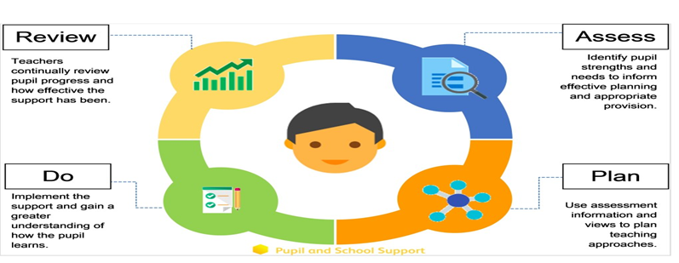

What kinds of Special Needs and Disabilities do we cater for at Hirst Wood Nursery School?
Here at Hirst Wood we are a generic setting which means that we cater for a wide range of needs including

- cognition and learning;
- physical and medical;
- hearing and visual impairments;
- dual and multisensory impairment;
- specific learning difficulties;
- communication and interaction difficulties such as Autistic Spectrum Condition;
- specific learning difficulties;
- social, emotional and mental health needs
- speech, language and communication needs.
Early Years Enhanced Specialist Provision Places (EYESP)
Early Years Enhanced Specialist Provision places can be allocated to children with Special Educational Needs and Disabilities through Bradford’s SEND Team. This means that children will be on a much smaller ratio with an experienced SEND practitioner to support them to access activities and make progress in Nursery. We offer Reception places to children where this is appropriate. Please note we do not allocate the EYESP places and a separate referral form must be sent to the SEND Team.

Education, Health and Care Plans “If the evidence from parents, the child, the school and other involved professionals supports the need for additional provision beyond what can be reasonably expected of a school or setting, then an Education Health and Care Plan will be written. This will detail and fund the additional provision.” If a child is on an EYESP place, the process will be started after approximately 12 weeks. The EHC Plan outlines a child’s needs and what provision would need to be put in place to support their learning. This is especially important as they move on to other settings. A child must have an Education, Health and Care Plan to be able to attend a Special School.

How do we identify children with Special Educational Needs and Disabilities?
There are a range of ways in which we identify children with Special Educational Needs and Disabilities. Some children will have already been identified before they start at our setting, in which case we work in partnership with the professionals that already know the child and their family to support their progress and learning.

The progress of all our children is monitored half termly, and children are identified during Pupil Progress and Inclusion meetings when their progress has been less than expected. If teaching teams consider that a child may have an additional need, or is not making expected progress, then they will discuss this with the SENDCo and parents in the first instance. The child will then be assessed in more detail and observed in an attempt to discover what is happening and why: support can then be tailored to their needs. We will observe them, and carry out further assessments to pinpoint what is causing the difficulty (what is happening and why). Staff in school may work with your child at this point in order to complete a range of assessments to highlight your child’s strengths and possible areas of weakness so that support can be carefully targeted to their needs. If appropriate, school will then seek the support of external professionals through a referral. In some cases, children may be referred for an Enhanced Nursery Place which usually triggers statutory assessment for an Education, Health and Care Plan.

What extra things can be put in place to help my child to learn?
Assessment Profile (Early Years Developmental Journal)
If a child is showing significant delay in an area or is on an Early Years Enhanced Specialist Provision Place, their progress is monitored through the use of the Early Years Developmental Journal, although sometimes this may be used in conjunction with Birth to 5 Matters. The journals run alongside the EYFS but are split into smaller steps to demonstrate the progress that children are making. They are split into the following areas: Personal, Social and Emotional, Communication, Physical and Thinking. Please see the example journal alongside this document.
All About Me
This document is used to collate all the valuable information we know about each child so that all staff know how best to help them to learn. We gather our information from families and our observation of children which is then shared with all the teaching teams.

Personalised planning
Some children may also have Health Care Plans / Medical Agreements, Safe Handling Plans, or Risk Assessments, depending on their specific needs. These are all reviewed on a termly basis to ensure that they are up to date and responsive.

Individual Intervention Record
This document highlights a timeline and outcomes of all support and referrals made e.g. Child Development Centre, SCIL team, Enhanced Nursery Place referral.

Partnership with other professional agencies
The SENDCo is able to gain advice or support from numerous professionals and services such as Speech and Language Therapists, the Child Development Centre, SCIL (Social, Communication, Interaction & Learning) Team, Audiology, Paediatricians to name a few. Staff may request support from specialist teams in the Local Authority services e.g. High/ Low Incidence Teams. A referral for an Enhanced Nursery Place may be requested or an Education, Health and Care Plan might be considered.

How could my child get help in school?
Children in Nursery with SEND will get support that is specific to their individual needs. This will be provided by all members of the teaching teams. We have two different types of SEND provision, all of which are in the mainstream School, which are SEN support and Early Years Enhanced Specialist places which is an allocation 10 places @ 0.6 attendance (children attending 30 hours will be the equivalent of 1.2 places).

The Woodlands team consists of a specialist teacher, 4 x early years practitioners and a teaching assistant, all with extensive experience.

We have a commissioned a Speech and Language worker every term who observes children and works with both individual children and in small groups to assess, advise, support and extend skills. This group is named Fundamental Foundations.

How do parents and staff work together to support my child’s development?
We believe strongly in working together with parents and carers and have a commitment to working together to coordinate our efforts to help every child to overcome barriers and achieve their full potential. Individual Education Plans are reviewed termly, with input from parents (and their child’s voice), teaching teams and any specialist advice. Teaching teams have a copy of every child’s IEP.

We also have Woodlands Wednesday, stay and play group where we invite parents and their child to a small group in the Woodlands Room and discuss a particular topic to share skills and strategies e.g. intensive interactions, communication methods, continence, behaviour.

How can I let the school know I am concerned about my child’s progress in school?
If you have concerns about your child’s progress you should speak to your child’s teacher or key person initially. If you do not feel satisfied, or your concerns have not been actioned or reassured, please speak to Jayne Taylor, Headteacher & SENDCo. If your worries continue, please contact the Governor for SEND (Ruth Trattles, Chair) via office@hirstwoodnscc.co.uk

How will the school let me know if they have any concerns about my child’s learning in school?
Where a colleague has raised concerns about your child’s progress, and targeted teaching has not met the child’s needs, the member of staff must raise this with the SENDCo and then discuss this with you. As with all members of staff, we have an open-door policy that actively encourages all staff to discuss their concerns about children whenever necessary. We have regular School Development meetings where teaching teams share their thoughts on children, progress and support strategies.

Our termly assessments will also highlight any developmental concerns. If your child is then identified as not making expected progress, the class teacher will discuss this with you in more detail and listen to any concerns you may have too. We share our assessment data with you via EYLog and this is discussed in more detail via the communication meetings.

How will the teaching be adapted for my child with learning needs?
Staff plan activities and experiences according to the specific needs of all groups of children and ensure that your child’s needs are met. All teachers are provided with information on the needs of individual pupils, so that they can plan the learning and activities to ensure that all pupils are able to make progress.

Differentiation is planned for groups and individuals according to need for example, for a child who has Speech, Language and Communication Needs (SLCN), teachers will use a Total Communication Approach which includes simplified language, pictures, Makaton signing, symbols or objects of reference to support them to understand new vocabulary. Planning and teaching will be adapted on a daily basis, and though in the moment planning to meet your child’s individual needs.

Children accessing the Woodlands (Enhanced Nursery Places) have different recording methods such as individual one to one work focussing on intensive interaction, time in the Nurture provision and the Sensory Room, all of which are planned, reviewed and discussed at the daily inclusion meetings.

All policies are written and reviewed with a commitment to promote equalities, including the interests of those with a disability or additional learning needs.

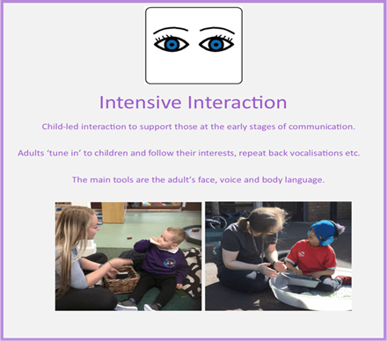
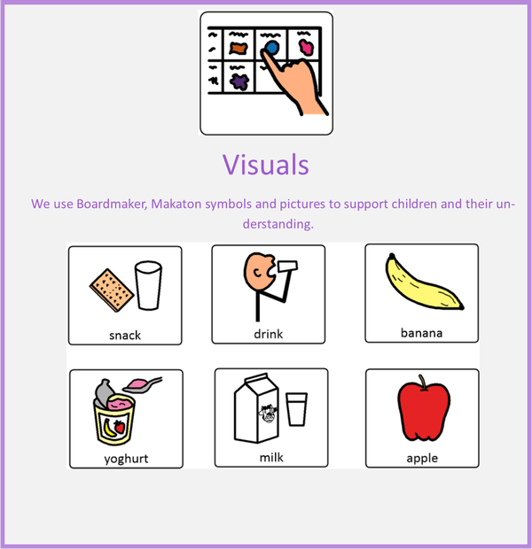
Visuals
We use Widgit symbols to support children and their understanding.
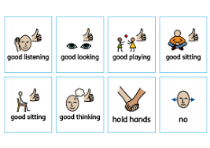

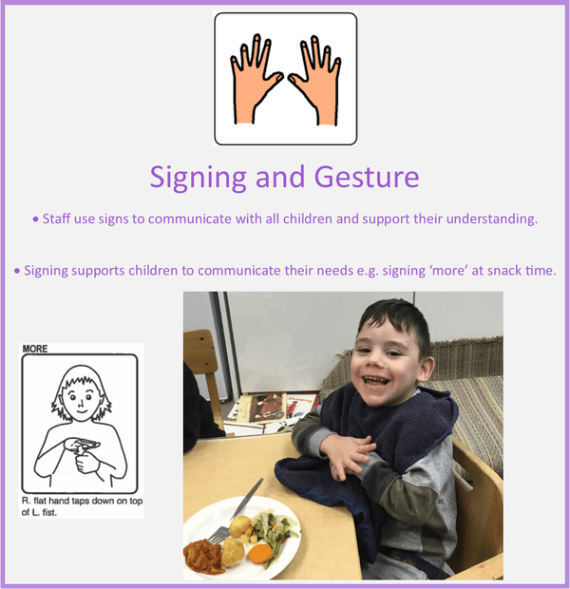
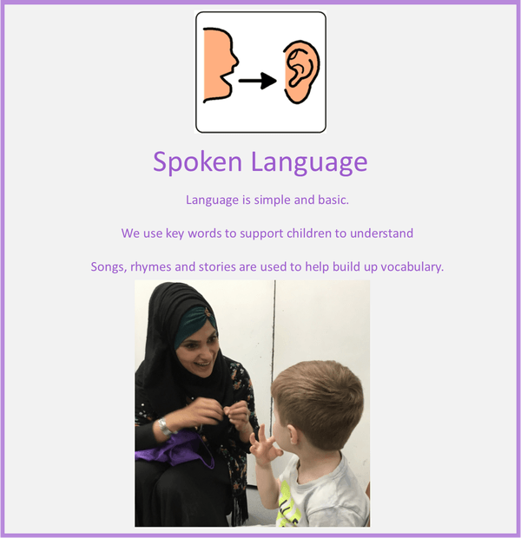

How does the school train staff and secure specialist expertise?
We offer a comprehensive training programme to ensure that our inclusive practice is of the highest quality. All staff have access to a range of continuing professional development opportunities, both through the School Improvement Plan and through their individual interests. We also arrange specialist training in relation to the needs of the children, for example if they required oxygen, or are tube fed.

The Headteacher/SENDCo acts as a link to a wide range of other specialist agencies, such as Speech and Language Therapy, SEND Support Services, Educational Psychological Service, Child Development Centre, Physiotherapy and Occupational Therapy, Hearing and Visually Impaired Services, and parent advice groups. The SENDCo is kept up to date with local and national developments around SEND and attends specific training updates.

What specialist services and expertise are available at or accessed by the school?
All external partners we work with are vetted in terms of safeguarding and when buying in additional services we monitor the impact of any enrichment against cost, to ensure a value for money service. Hirst Wood commission a Speech and Language Therapist weekly and find their expertise to have a very positive impact on children, families and staff.

We also have access to a wide range of specialist support via referral to the Local Authority.

What support do we have for you as a parent/ carer of a child with SEND?
We strive to promote positive reciprocal relationships between School and home to ensure that we are working in partnership and ensuring consistency, sharing strategies and support. The Headteacher/SENDCo is available to meet with you to discuss your child’s progress or any concerns/worries you may have. All information from outside professionals will be discussed with you with the person involved directly, or where this is not possible, in a report. The SENDCo will also arrange to meet with you to discuss any new assessments and ideas suggested by outside agencies for your child.

We also have our Woodlands Wednesday group that is exclusively by invitation only for parents and children with SEND to speak openly in a warm and supportive environment. These sessions are hosted by Woodlands colleagues.

How will my child be included in activities outside the classroom including school trips?
We actively ensure that all our enhanced activities are accessed by all children. This has led to us creating our own Forest School on site and means we bring experiences to Nursery e.g. a farm. Risk assessments are carried out and procedures are put in place to enable all children to participate. Our Accessibility Plan is reviewed regularly.

How have we made sure Hirst Wood Nursery School is accessible to children with SEND?
As a school we are happy to discuss individual access requirements and have created a fully accessible site. Each classroom has ramp to provide wheelchair access to the outdoor area. Each classroom uses visual labels and Makaton signs. We also use visual aids and objects of reference in school to support learning. Children also have their own visual systems such as timetables, picture exchange card systems, Now and Next boards.

We have two hoist systems in place to support the children with complex physical needs. We have an Accessibility Plan on our website with up to date information as well as our plans for future adaptations. We are very reflective and responsive, so whatever changes need to be made for children to achieve and succeed will be made immediately.

How do we support improving emotional and social development?
The school takes pride in its friendly and positive ethos. Clear and well-established positive behaviour policies help all pupils. Each of the classrooms has an ‘emotions board’ where children are encouraged to check in and place their name card under the headings of sad / happy / cross to demonstrate how they are feeling. This is, of course, explained to children and an adult model and supports the process of children working towards emotional literacy. We also use lots of group times to discuss challenges and have Persona Dolls to talk through any challenges that children may be facing.

As a staff team, we have looked at our emotional curriculum and devised a repertoire of strategies that uses a zones of regulation approach, but is age appropriate for young children. Occasionally, if a child needs a Safe Handling Plan, this will be drawn up in consultation and agreement with parents.

How will we support your child when they are leaving this school or transitioning to a different setting?
We recognise that moving on can be difficult for most children, but especially for those who have additional challenges. We personalise our transition to ensure that these are as smooth as possible. If your child is moving to another school we will contact the school SENDCo and ensure they know about any special arrangements or support that needs to be put in place for your child. The SEND Team will arrange additional visits to new schools for your child and personalised resources to support transition may be used. Staff from the receiving school are encouraged to visit us to see your child in their current setting. We will make sure that all records about your child are passed on as soon as possible.

How does Hirst Wood Nursery School involve other bodies, including health and social care bodies, local authority support services and voluntary sector organisations, in meeting children’s SEND and supporting their families?
There are many local and national organisations who can offer support and advice, including some charities and voluntary bodies. A good place to start is the Bradford Parent Partnership, whose website can be found at http://www.barnardos.org.uk/parentpartnershipservice.htm (phone: 01274 481183).

The SEND Team are available to help parents locate organisations that can offer more specialist advice. City of Bradford Metropolitan District Council Services: Switchboard: 01274 432111; www.bradford.gov.uk

Disabled Children’s Information Service Produce a monthly newsletter for families who have a child with SEND. Contact: 01274 433861

Support for parent carers in the Bradford District - https://www.carersresource.org/ Autism support - https://aware-uk.org/ https://www.barnardos.org.uk/

Bradford Actionaires for the blind and visually impaired - https://www.rnib.org.uk/ Bradford disabled sports - http://www.bradforddisabilitysports.co.uk/

Family Centre Service
Provide support and fun activities to help young children’s early learning and development; including activities for children with SEND and their families. For details of a centre in your area, contact the Families Information Service.
Families Information Service (FIS)
Information on childcare and short breaks, finance and benefits, health services, Portage, and local support groups for children with SEND. Contact: 01274 437503; 01274 431252 (Urdu, Punjabi); 01274 434905 (Eastern European).

Local Offer Bradford
The Local Offer provides web-based information on education, health and social care for families with a child aged from birth to 25 years who has SEND. www.localoffer:bradford.gov.uk

Portage Service
A home-visiting learning support and advice service for children with SEND (birth to 5 years). Contact: 01274 439500; www.portage.org.uk

Family support for children with Autism
If your child is autistic or is under-going/awaiting an autism diagnosis the websites below provide support, resources, and advice.
- AWARE (aware-uk.org) – a parent-run group supporting families with children and young adults on the autistic spectrum (formal diagnosis is not required). The group covers the Airedale, Wharfedale, Bradford and Craven areas and beyond.
- National Autistic Society (autism.org.uk) – offers a range of resources and advice, working to transform lives and change attitudes to help create a society that works for autistic people.
- Ambitious about Autism – a national charity for autistic children and young people, providing information and practical support and delivering specialist education and employment programmes.

How do we handle complaints at Hirst Wood Nursery School?
Most complaints are resolved readily and informally by discussion, however if a resolution is not agreed, the matter may be escalated to the Headteacher/SENDCo. Beyond this, a complaint may be taken to the Governing Body or the Local Authority.

Contact details for any concerns, complaints or guidance
Jayne Taylor, Headteacher & SENDCo
Jayne.taylor@hirstwoodnscc.co.uk

Local Authority Offer for Special Educational Needs & Disabilities
Bradford Local Authority Local Offer - https://localoffer.bradford.gov.uk/

Admissions
To request a place, parents are requested to an admission form which should be returned to Reception. We would actively encourage parents/carers to request a tour of our setting.

The Hirst Wood Nursery School SEND support offer

Overview of 2024 cohort (as at 27th November)

Number of children on SEND register | 10
Number of children receiving SEND Support | 10
Number of children with EHCP | 3
Number of children on Enhanced Nursery School Place | 10

