Week beginning Monday 14th June 2021
Willow

Book of the week:  Who Sank the Boat  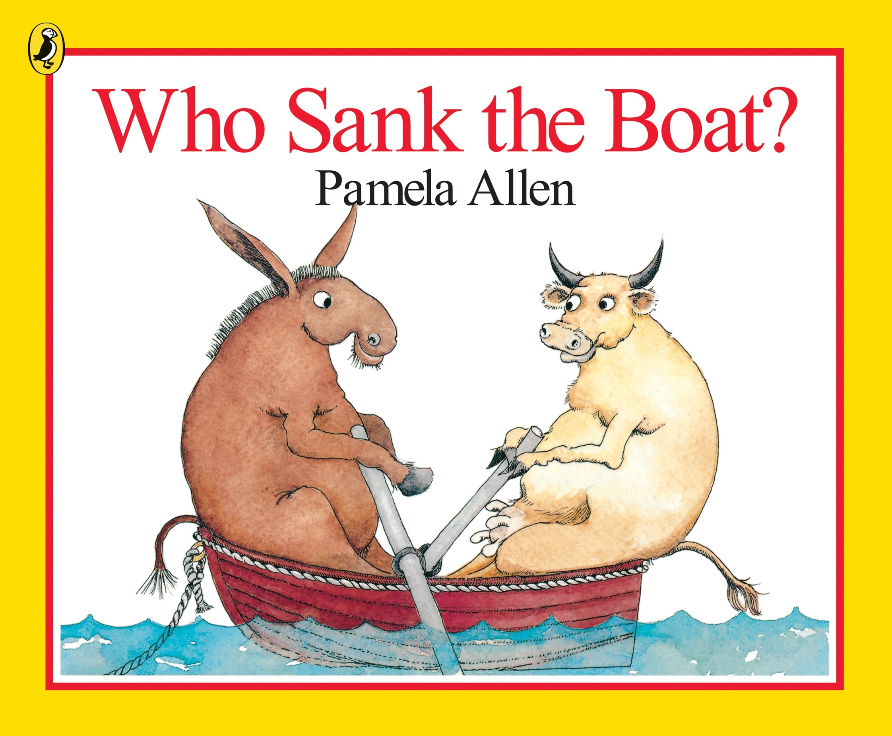 | Rhyme of the Week:  Row Your Boat  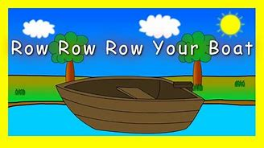 |  | Help at Home:  Gather some objects from around the home and test whether they will float or sink in water.  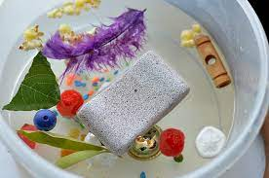
Sound of the week:  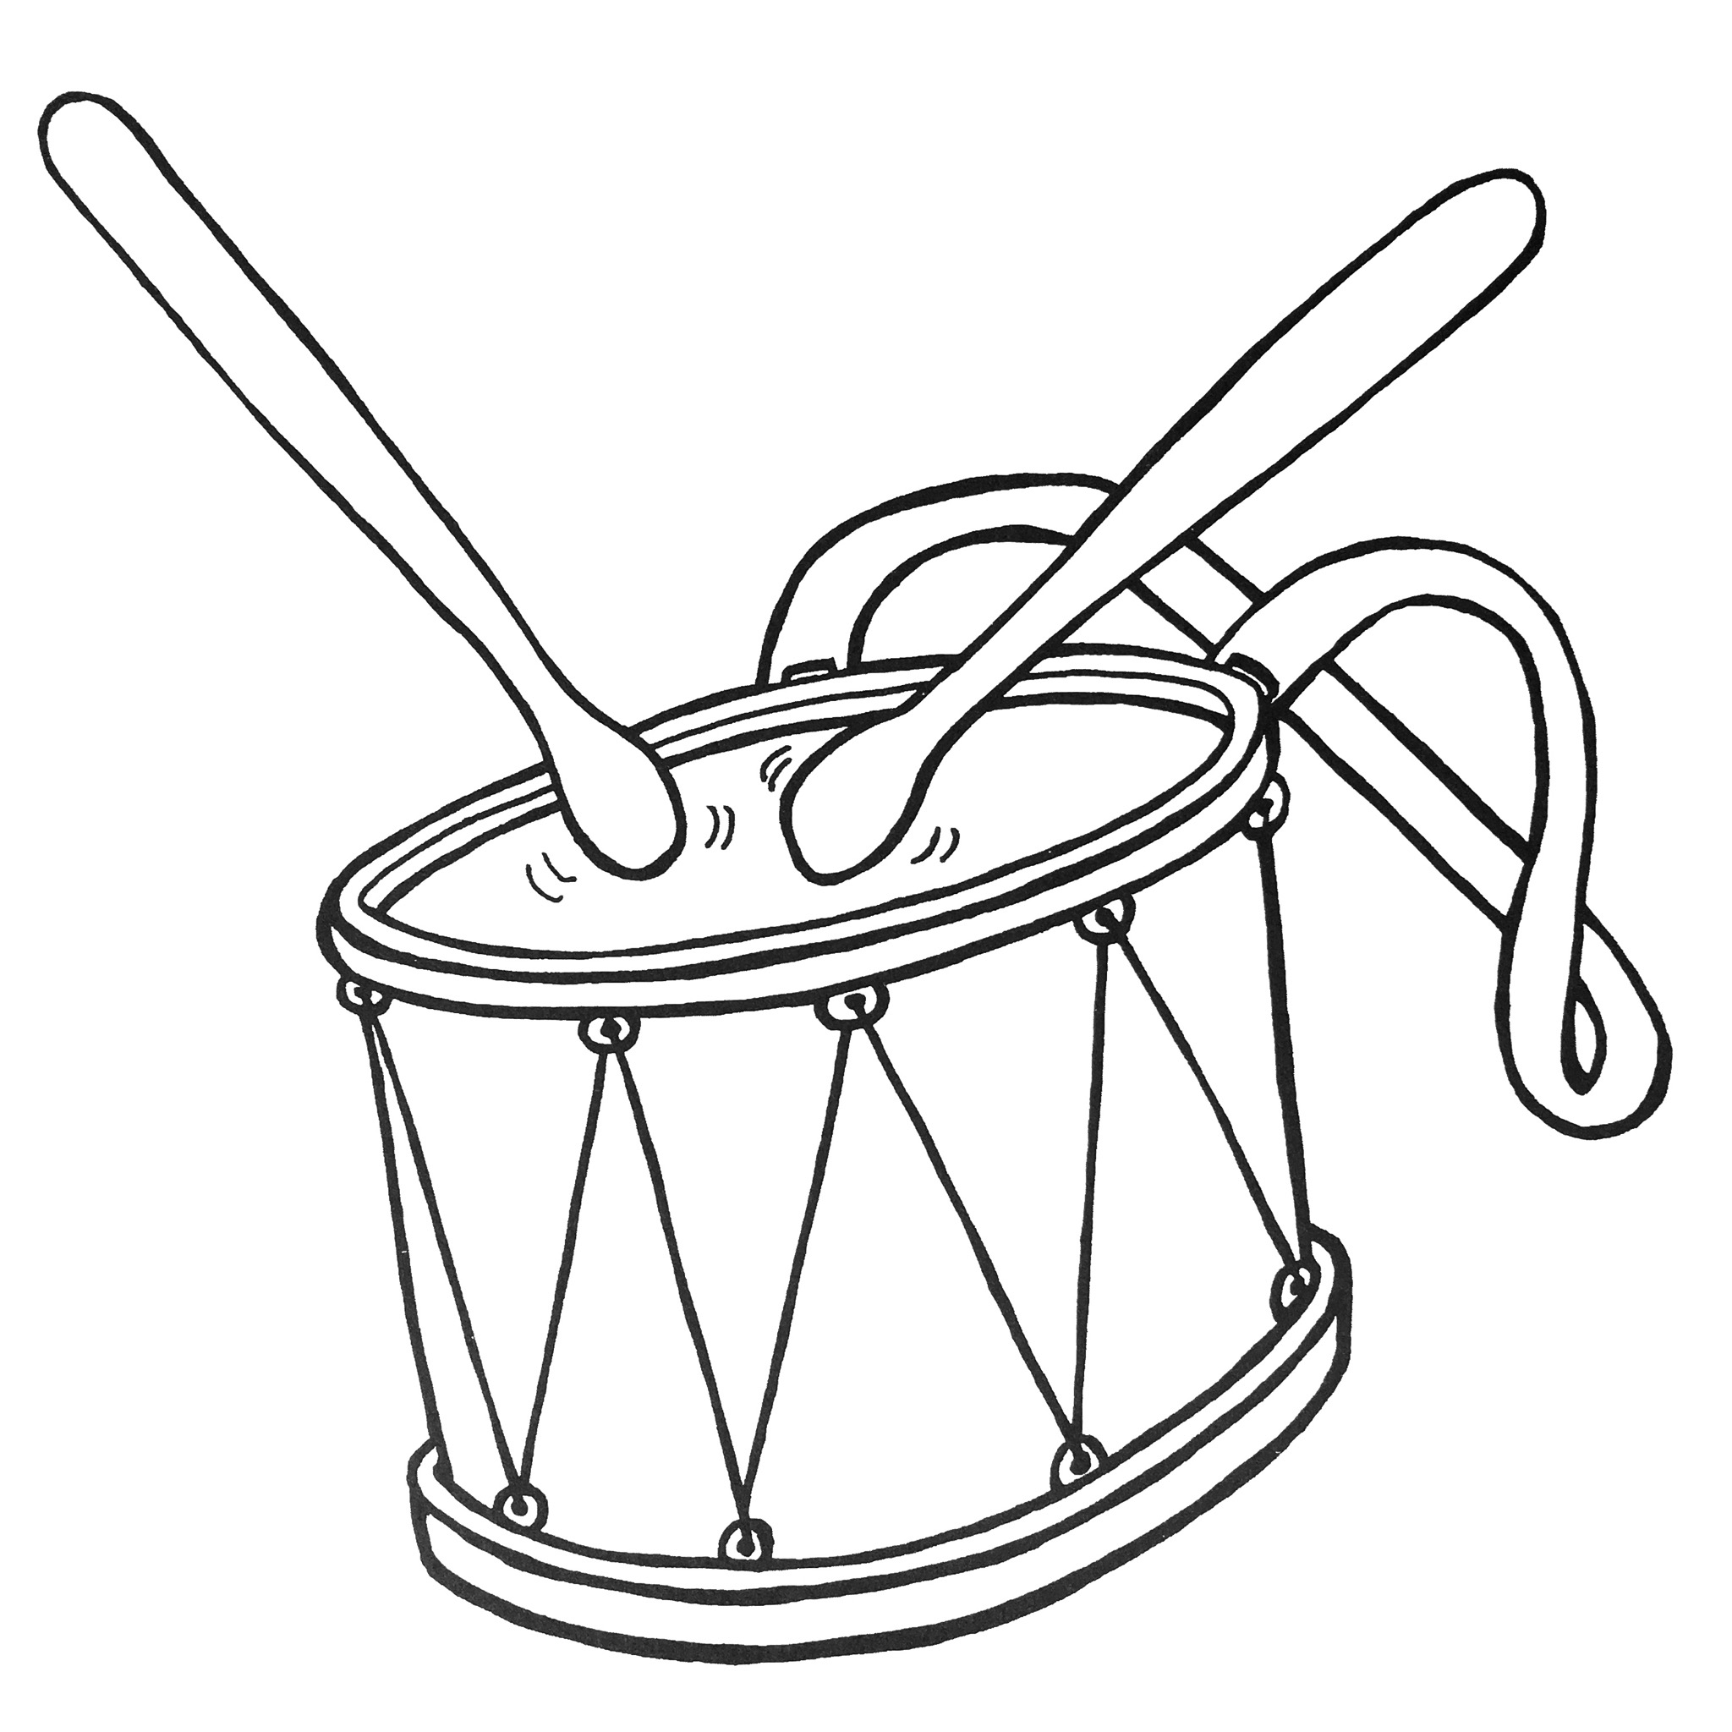  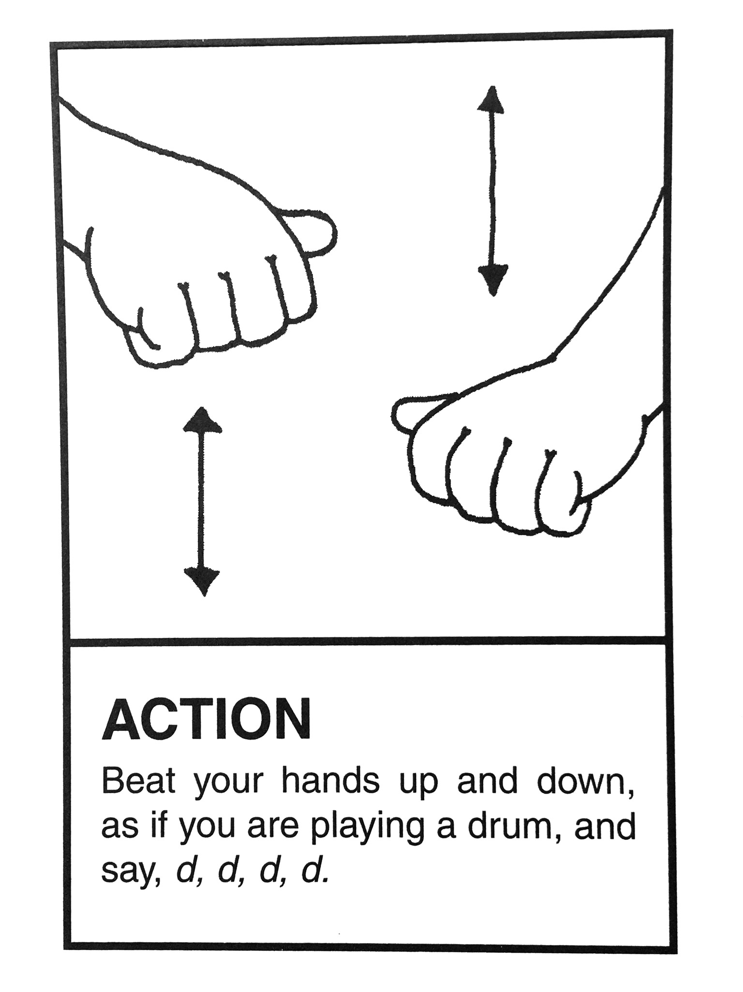  D d | Number of the week:  8 eight  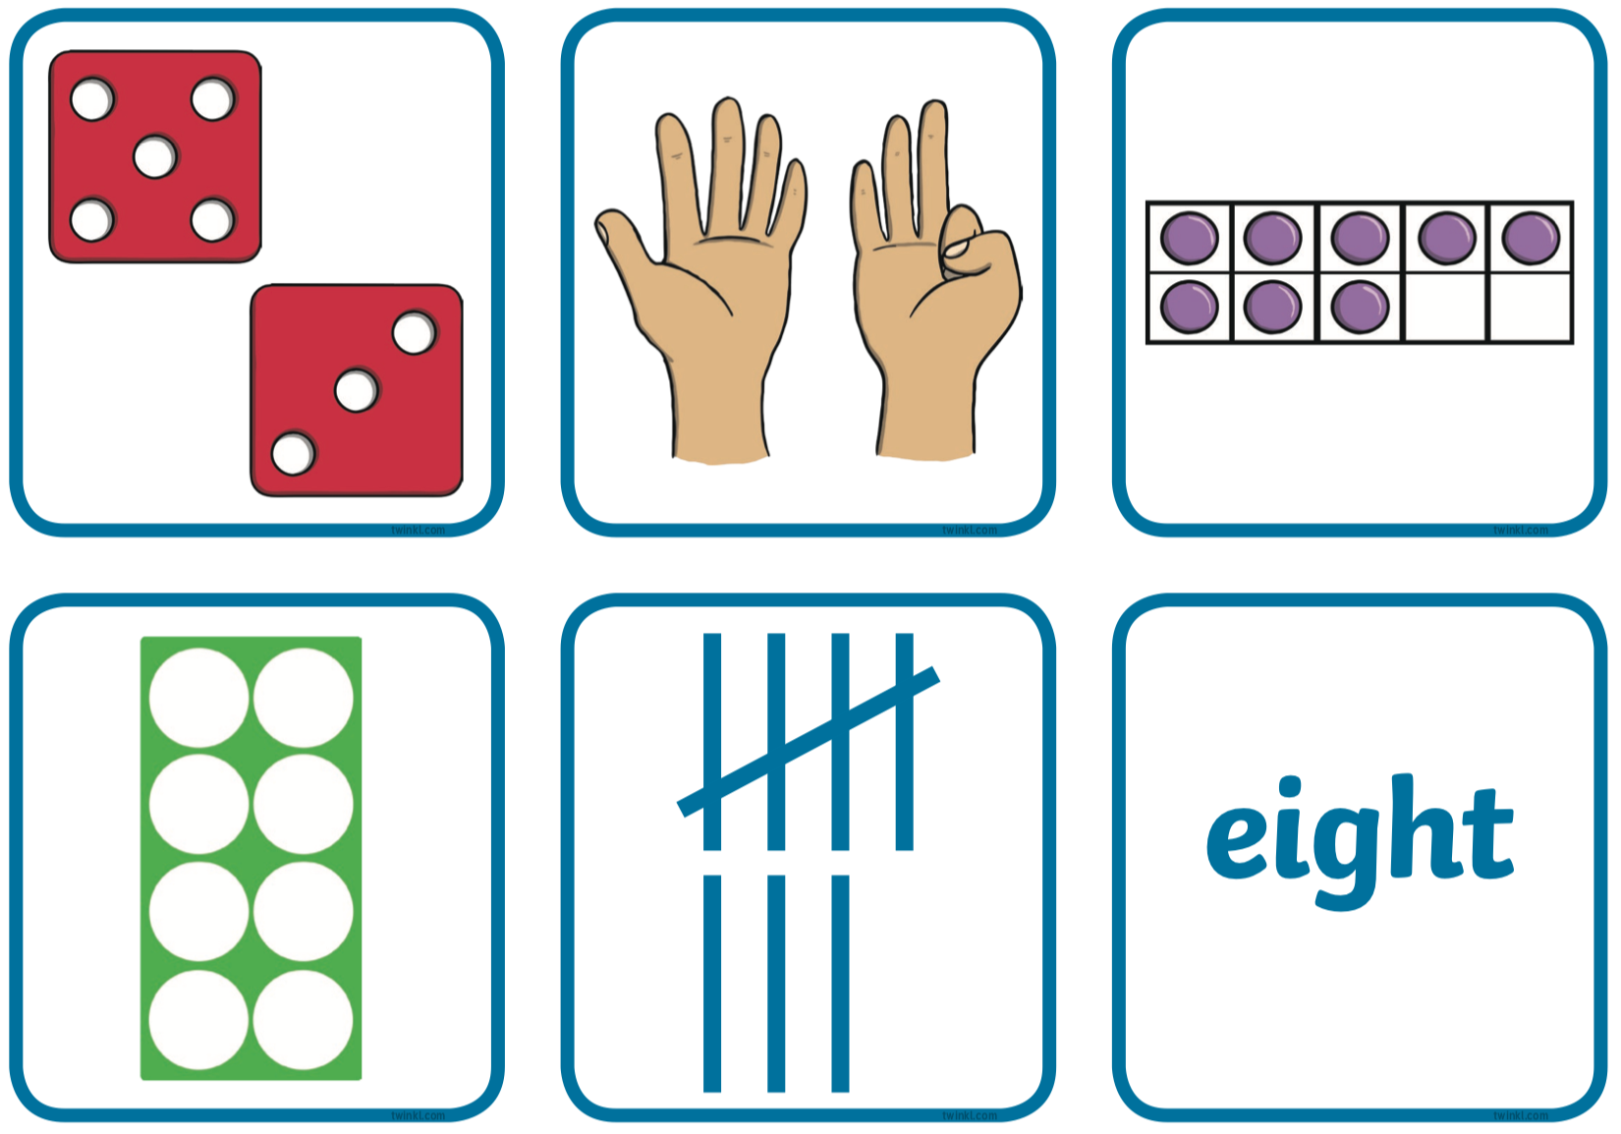 |  | Sign of the week:  paint  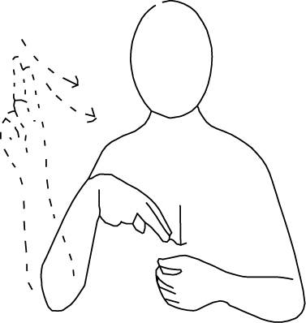
Indoor learning:  - Using our creative skills to make bottle top boats.  - Exploring capacity using different containers.  - Drawing our own representations of who we think sank the boat in the story.  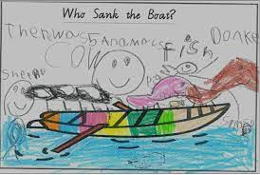 |  | Outdoor learning:  - Testing whether our bottle top boats will travel down guttering using water.  - Using large loose parts to create a boat whilst retelling the story of the week.  - Exploring the texture of corn flour.  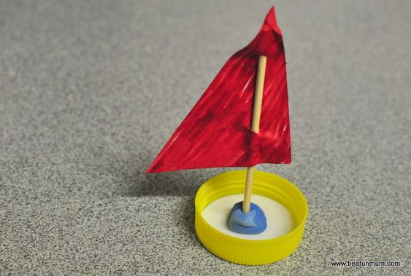
We are here to help. If you have any questions or concerns please telephone the office.
Ruth, Angie and Kath

