Week beginning 5th May 2026
This week in Chestnut
We are here to help. If you have any questions or concerns, please talk to your child’s keyworker or any of the staff.
Book of the week:  The Very Hungry Caterpillar  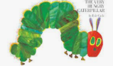 | Rhyme of the week:  Little Arabella Millar  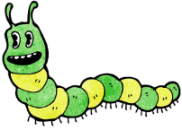 | Sign of the week:  Girl   | Happy Thought of the week:  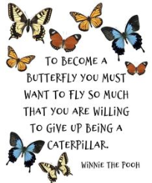

Maths  We will be:  - Continuing to write numerals 1–5, forming each number using a “magic finger” in the air, copying adult modelling, and attempting to record numbers on paper.  - Building simple towers of 3,4 and 5 using Duplo bricks, for example 2 blue and 1 red. We will then practise describing our towers using language of composition e.g. “my tower has 2 blue bricks and 1 red brick. That’s 3 bricks altogether.” | Phonics Phase 1 Aspect 7 – Oral Blending and Segmenting  We will be:  - Placing the children’s name cards in the centre of the circle and asking them to find their name and put it in the box, supporting them to recognise and begin to read their own name.  - Saying simple CVC words by first breaking them down into sounds and blending those sounds together. We will ask the children to listen carefully, then we will model blending the sounds together and encouraging the children to join in (e.g. “c-a-t… cat!”).
Learning Opportunities  We will be:  - Observing and discussing our classroom caterpillars to help children begin to understand that living things change over time. The children will use simple language to describe what they see and  - Introducing the key stages of the life cycle of a caterpillar (egg, caterpillar, chrysalis, butterfly) through discussion.  - Continuing to look at photos of the children at different ages and encouraging them to notice similarities and differences over time.  - Exploring remote-controlled cats, where children take turns using simple controls to make the cats move, stop, and turn. | Help at Home  Blending CVC words  Support our phonics learning in class by regularly saying simple CVC words in sounds (e.g. “c-a-t”) and helping your child blend them together to say the whole word (“cat”). This can be made into a fun game using everyday objects around the home, such as “c-u-p” or “b-e-d,” encouraging children to listen carefully and join in. Keep it playful, repeat words often, and celebrate attempts to build confidence in early reading skills.

Dates for your diary:
- Wednesday 6th May - School photographs.
- Week commencing 11th May - We are Healthy Week.
- Tuesday 13th & Thursday 15th May – Healthy lunch and balance bike sessions from Ready Steady Peddle for We are Healthy Week.
- Wednesday 13th May – Visit from Coram SCARF Education Life Caravan for We are Healthy Week.
- Wed 20th May - Sing-a-long fundraising event.
- We close for May Half Term on Thursday 21st May (Friday 22nd is a training day) and return on Monday 1st June for Summer 2 term.

Little Arabella Millar

Little Arabella Miller
Found a furry caterpillar
First it climbed upon her mother
Then upon her baby brother
"Ugh" said Arabella Miller
"Take away that caterpillar!"

*To the tune of Twinkle Twinkle Little Star

