Week beginning Monday 27th January 2020
This week in Chestnut

Book of the week:  Information Texts  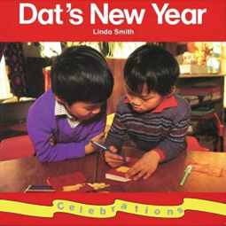 | Rhyme of the week:  Dragon Dragon |  | Sign of the week:  please
Sounds of the week:  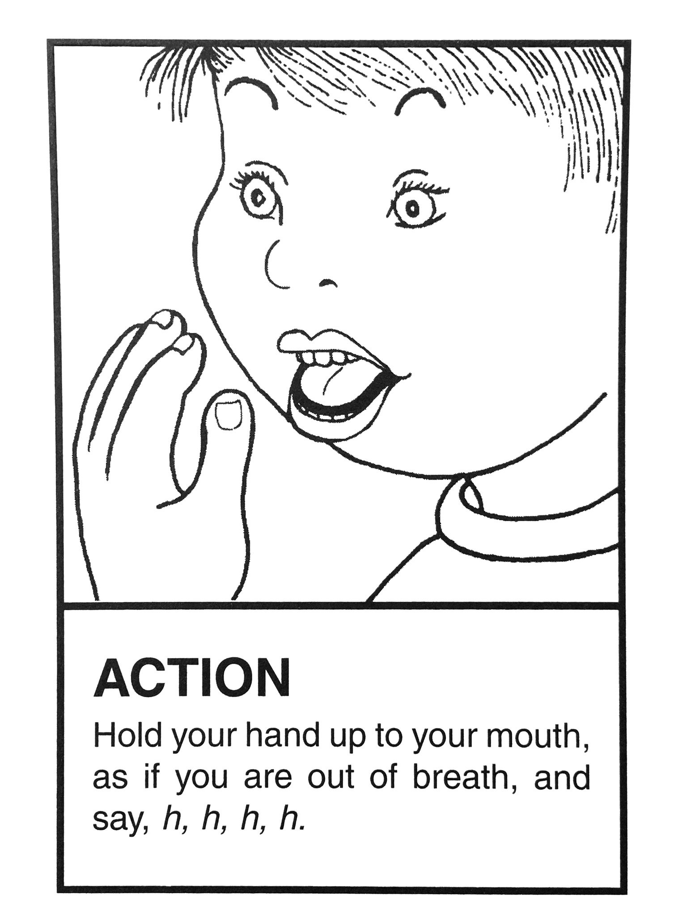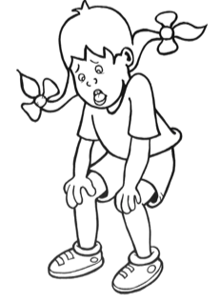H h | 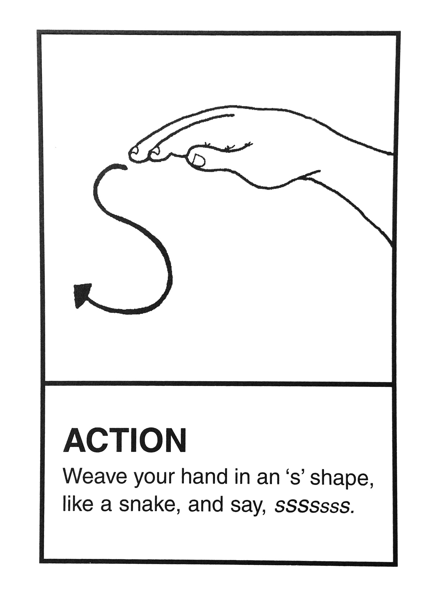S s  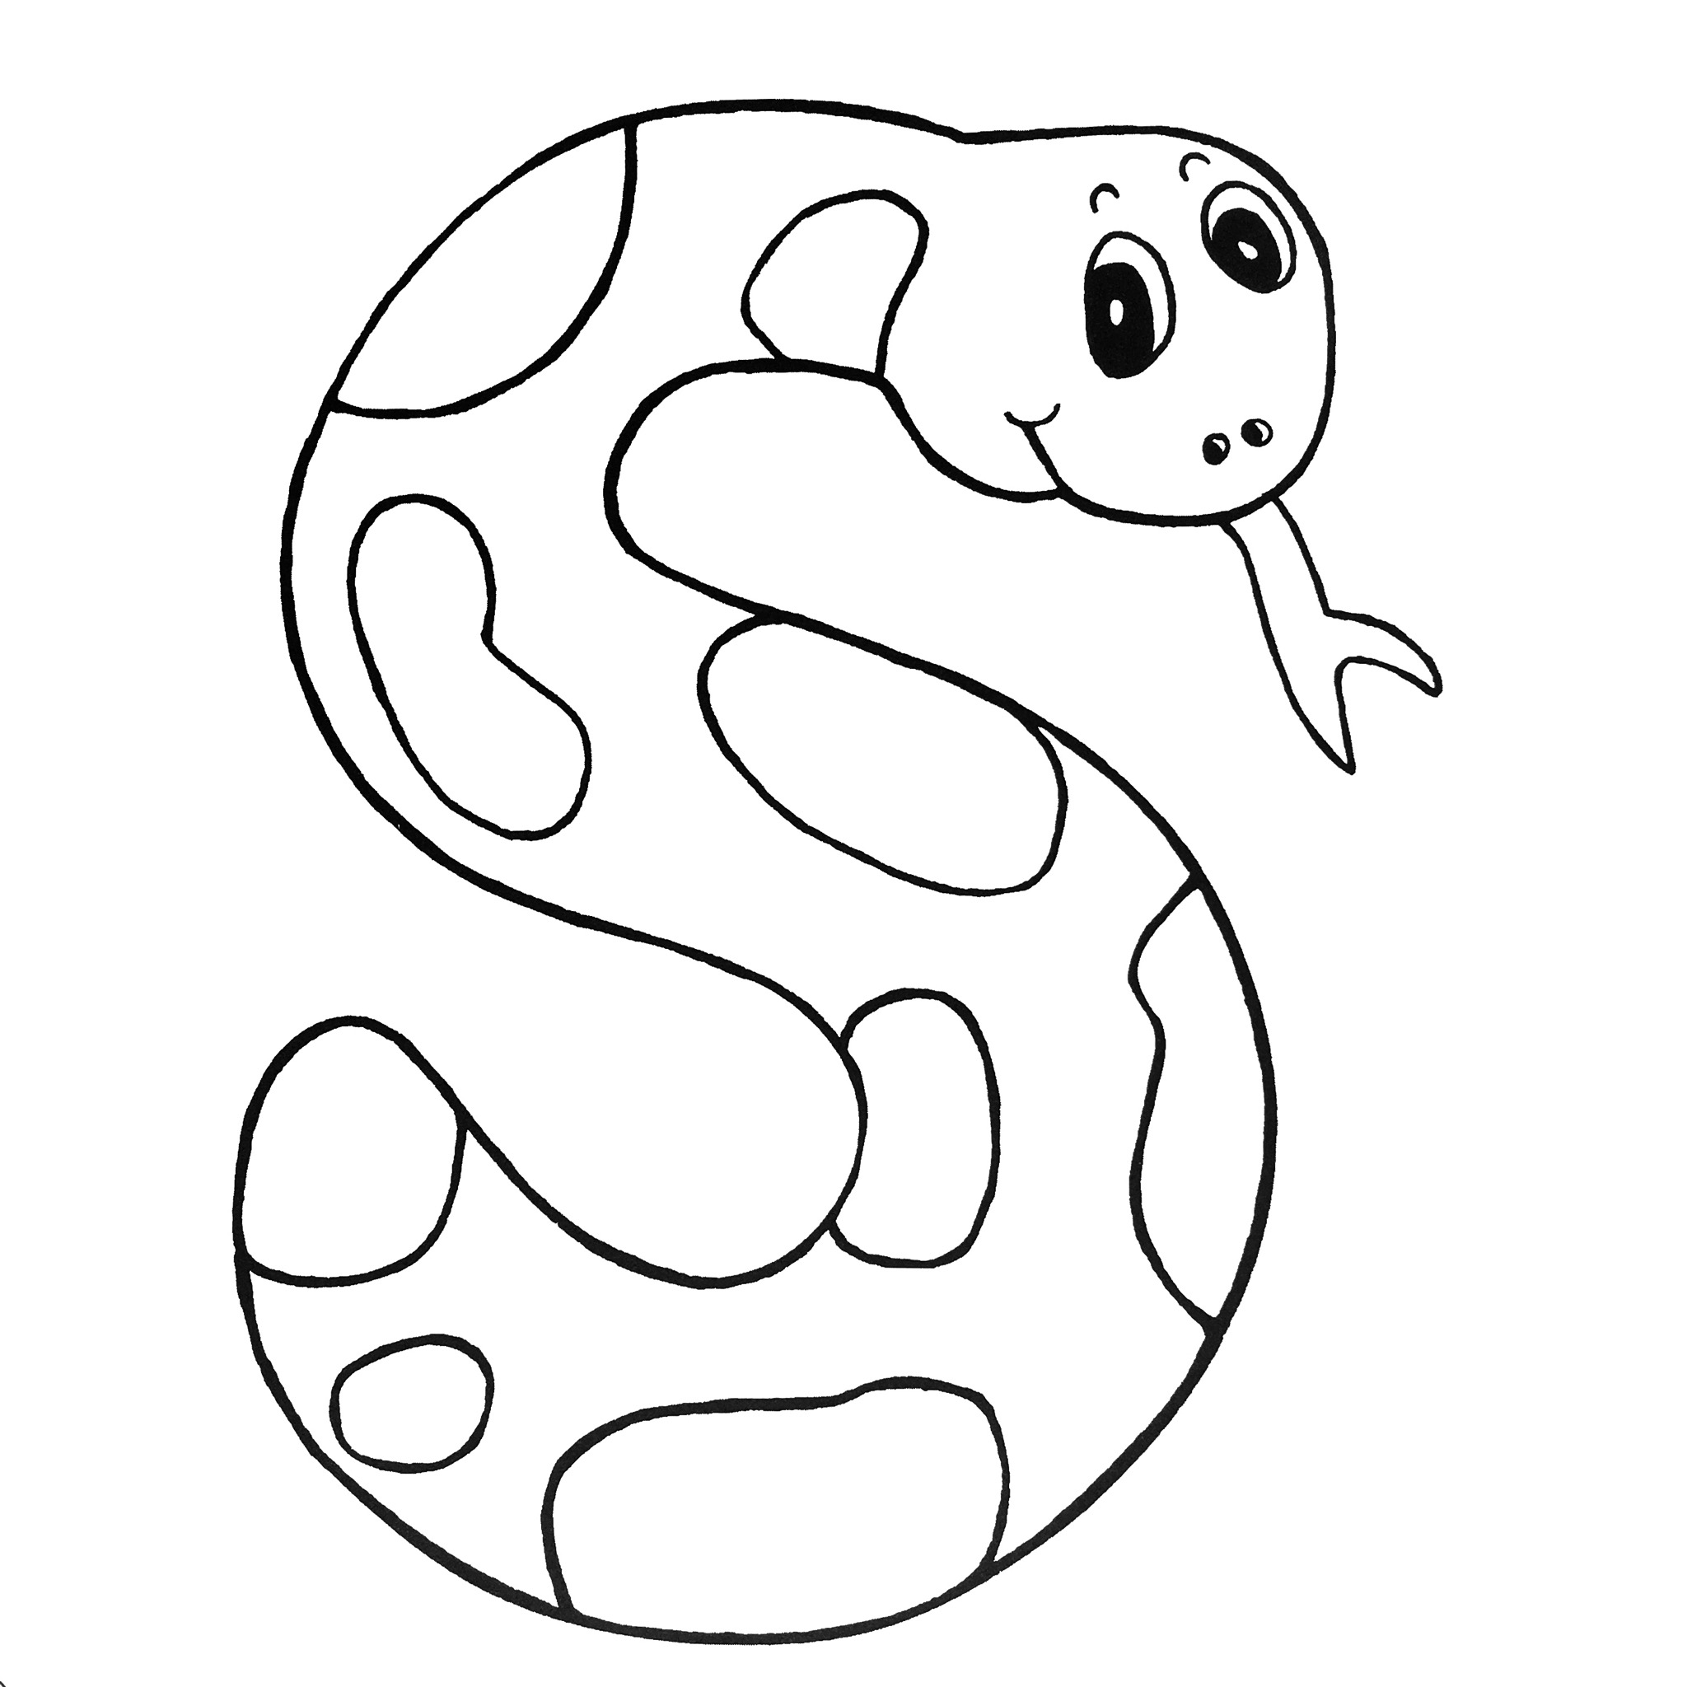 |  | Number of the week:  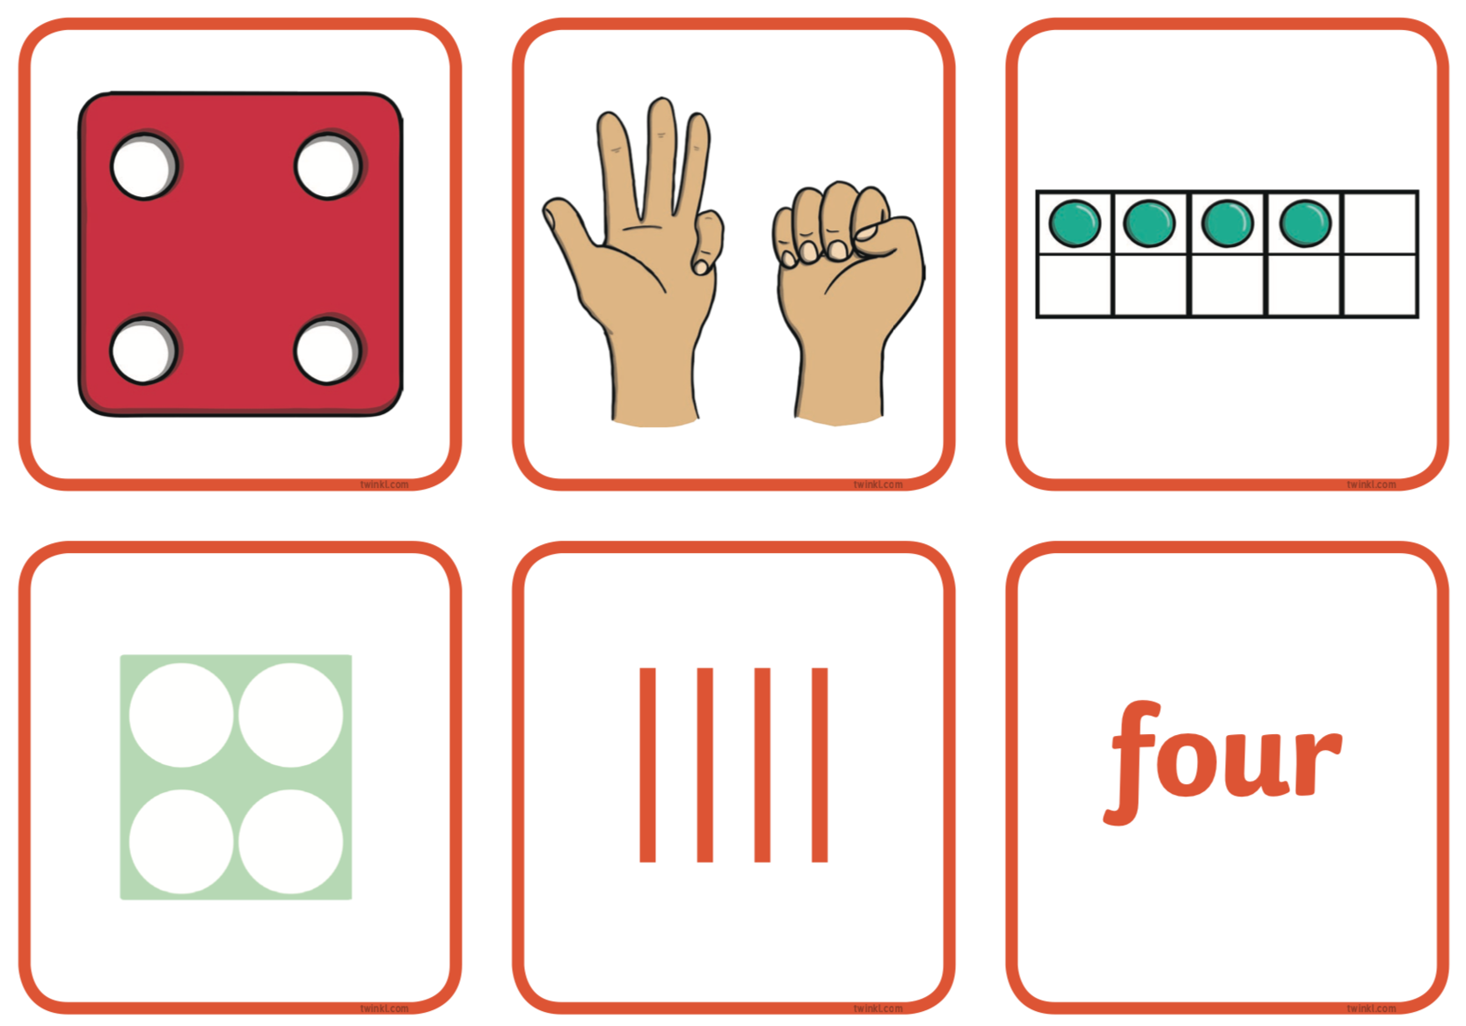 4
Outdoors:  - noodle sensory play  - creating a Chinese dragon  - developing co-ordination through music and movement  - painting on a large scale  At Forest School:  - being ‘wild things’ in the  wilderness Garden  - making headdresses  with natural materials |  | Indoors:  - developing our scissor skills  - investigating floating and sinking  - learning about time  - sampling noodles and using chopsticks  - making marks and early writing  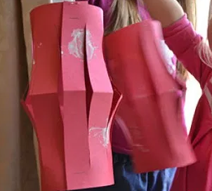
Dates for your diary:
Wednesday 5th February - Maths Day. If possible wear something with a number or a pattern.
Friday 28th February 9.00-9.30am – Stay and Learn about Phonics
Wednesday 4th March - Bedtime Story Evening 4.30-5.00pm. Put on your onsie and join us for a bedtime story and hot chocolate.
Wednesday 11th March 9.00-9.30am – Stay and Play for Grandparents

We are here to help. If you have any questions or concerns please talk to your child’s keyworker or any of the staff in Chestnut Sally, Richelle, and Kath

