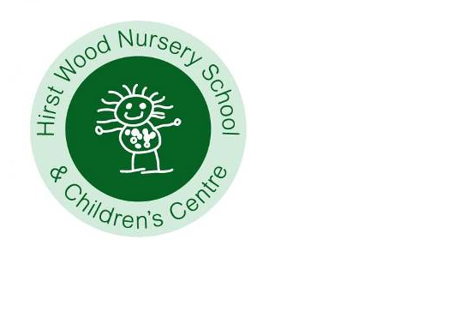
April 2023
Teaching and Learning
Welcome back, we hope that everyone enjoys a relaxing Easter break. We are delighted to welcome new children this half term and are sure that you will make everyone feel welcomed. The weekly planning is available on the website www.hirstwoodnscc.co.uk and on the noticeboard outside. This will explain to you what activities we are doing and how this supports your child's learning. We would also love to see what you have been enjoying at home so please upload photographs and information via EYLog that we can share with the children. Don’t forget that children can change their library books every day – just bring your book back and swap it for another. Please return all books as our stock is running low. Research shows that involvement with reading activities at home has significant positive influences not only on reading achievement, language comprehension and expressive language skills, but also on children’s’ interest in reading, attitudes towards reading and attentiveness BUT above all, it is enjoyable! We have the adult’s lending library too … take a book to enjoy yourself.

By now you will have received your child’s Primary School allocation for September. We are starting to work with the Schools who will be welcoming your children in September. We encourage them to come and visits your child and talk to the teaching teams so that they can share all the amazing information about your child. The receiving schools will also be provided with a copy of your child’s leavers report and their final assessment data. All these documents will, of course, be shared with you towards the end of next term. For those children who are leaving us, please see the link below about what we feel are important in terms of ‘school readiness’. This is formed on a whole child approach and covers predominantly the personal, social and emotional skills that will support children as they move to a new setting. Some children suffer from increased anxiety when there is lots of talk about transitions, it may be worth considering how soon you start to talk to your child about moving school. PowerPoint Presentation (pacey.org.uk)

Our curriculum approaches

Some learning is hierarchical, you need to learn things in a certain order and you need to be secure in the earlier steps before you move onto new content, but some learning isn’t like this. For example, as children learn more vocabulary, they will learn lots of different words. We don’t have a list of the order of learning. We need to know your children, spend time with them, working with and alongside, observing what they do, how, what and who with. We constantly ask ourselves, do we know enough about children and their learning? Are they making progress in our curriculum? We use three main techniques to ensure that our teaching and learning ensures children are engaged and adding to their skills, knowledge and understanding - scaffolding, feedback and metacognition.
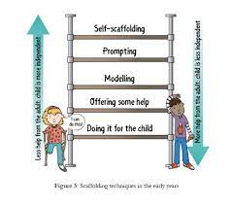
Scaffolding means that we give a child just enough help to do something which they couldn’t do independently. We gradually reduce the help until the child is independent. It’s a powerful technique for all children. It helps children with SEND to work towards the same learning goals as other children, with additional help along the way.

Feedback means that we give children precise information about how well they are achieving something. That means that we need to talk with children first, or during their activity, about what their intention is. Feedback is sensitive, and it avoids general praise. It focuses on process and effort, as well as the final result. It helps children to improve their learning. We can usefully encourage children to seek feedback from each other.

Metacognition is about children’s ability to plan ahead, monitor how well they are doing, make adaptations as they go, and review the final result of what they have been doing. That means providing challenging activities for children, to encourage them to think ahead and adapt as they go (e.g. riding a balance bike through an obstacle course). It means we need to talk to children about their thinking, planning, and end result. We do this through our displays that celebrate children’s learning, and also Eylog. We can usefully model metacognition, and talk about thinking and planning with children so that they view themselves as confident, successful learners, which of course, they are.
This half term we have some more exciting experiences planned for children

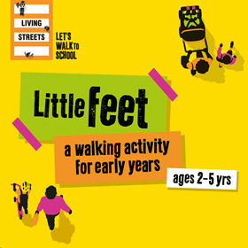
Wednesday 3rd May we have Little Feet coming in. Little Feet is a new walk to school initiative specifically aimed at children aged 2-5 years to promote healthy travel habits from a young age. Little Feet’s journey maps, stickers and educational games are designed to reward families for their walking journey and walking successes (cycling and scooting count too!) instilling healthy habits for life. The successful delivery of the project relies on a shared responsibility between early years setting and parent/carers. Children will learn about the benefits of being healthy more easily if they hear the same messages from School and home


To celebrate the King’s Coronation, we would like to invite you to join us for a garden party on Friday 5th May between 2.00 and 3.00. Scones with jam and cream will be provided. Feel free to wear red, white and blue. Please let us know if you are able to join us by emailing office@hirstwoodnscc.co.uk by 28th April. Thank you



Week commencing 9th May is our biology week and will be exploring how our body works and how we can look after it. We have balance bikes in the car park Tuesday 9th and Thursday 11th – all children will have the opportunity to participate (we will send home a copy of our risk assessment so that you can agree to your child taking part).


We have the Life Caravan visiting Wednesday 10th May where children can learn about all the different senses we have, the bones and organs in our body and how to look after ourselves. They also get to meet Harold, the giraffe, (the mascot of Life Education Centre).

The Flouride varnish team are here Wednesday 17th May – don’t forget if you would like your child to participate, please complete and return the signed forms. It is important to promote effective oral health habits from the earliest age. Tooth decay is largely preventable, but it’s still a serious problem among young children. Nearly a quarter of 5 year olds in England have tooth decay, with 3 or 4 teeth affected on average, unfortunately Bradford has much higher numbers than other parts of the country. Tooth extraction is one of the most common procedures for children under 6 years of age in hospital. Extraction is also the most common reason for hospital admission for children aged 6 to 10. We will be providing resources, hints and tips to support your child with healthy habits.

Tempest Photography are here on Wednesday 24th May. If you would like your child to have a photograph with their sibling(s) please let us know in advance and we will plan for this to happen before School.

Health & Safety

During the summer months it may be necessary that children need sun protection to be applied (hopefully!). In this respect we will provide sun cream for each classroom unless your child has specific skin sensitivities that would necessitate the use of their own specific cream. If this is the case, please bring in the sun protection clearly labelled with your child’s name. If you could apply sun-cream to your child before they come to Nursery and we will reapply it later in the day. Whilst we do have a stock of sunhats if you would prefer your child to wear their own could you please ensure that they are named (written in pen on the inside is fine). Thank you

Dates to remember:
We are closed Monday 1st and Monday 8th May (bank holidays)
We have two training days on Thursday 25th and Friday 26th May so close to children on Wednesday 24th May and return Monday 5th June

